Name _________ Date _________

BIO SOL Review 11 - Environments - Biomes, Ecosystems, Human impact (26)

- (2006-43) Some plant roots grow with mycorrhizal fungi. The fungi absorb water and minerals and pass them on to the plant and receive carbohydrates from the plant. This is an example of —
  - mutualism
  - competition
  - predation
  - parasitism

- (2001-16) A symbiotic relationship in which one organism benefits while one organism is harmed is known as:
  - antagonism
  - commensalism
  - parasitism
  - mutualism
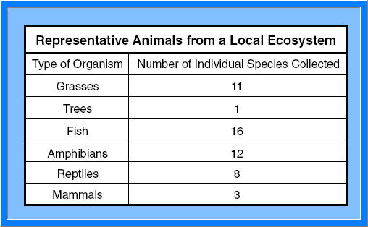
- (2006-39) The chart shows the types of organisms and the numbers of species collected from a local ecosystem. According to these data, this ecosystem was most likely a:
  - savanna
  - desert
  - tundra
  - marsh

- (2003-49) In which biome do the evaporation rates exceed the precipitation rates?
  - Hardwood forest
  - Desert
  - Grassland
  - Tropical jungle

- (2003-43) Which of these is the greatest limiting factor for plants that grow on the floor of a rain forest?
  - Herbivores
  - Water
  - Sunlight
  - Space

- (2005-29) The organisms in a typical backyard are likely to include bacteria, grass, shrubs, trees, insects, spiders, birds, and small mammals. Together, all these organisms make up —
  - a population
  - an experimental group
  - a community
  - a kingdom
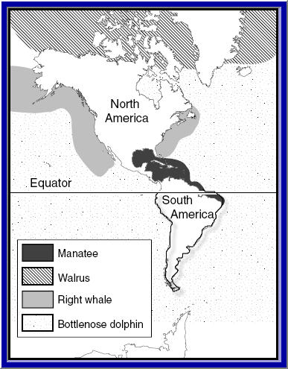
- (2006-9) According to this map, which animal would most likely avoid cold waters?
  - Bottlenose dolphin
  - Right whale
  - Walrus
  - Manatee
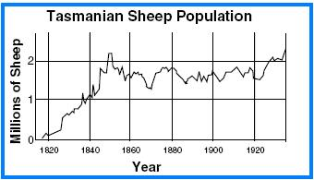
- (2005-37) This graph suggests that from 1840 to 1920, the carrying capacity for sheep in Tasmania was approximately —
  - 0.75 million
  - 1.00 million
  - 1.75 million
  - 2.25 million
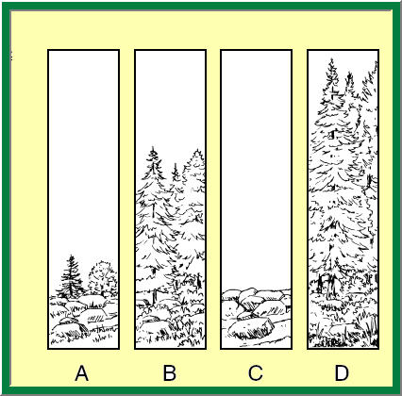
- (2001-48) Which order of diagrams would show primary succession in an area that had never before been occupied by living organisms?
  - D, B, C, A
  - C, A, B, D
  - A, C, B, D
  - B, A, C, D
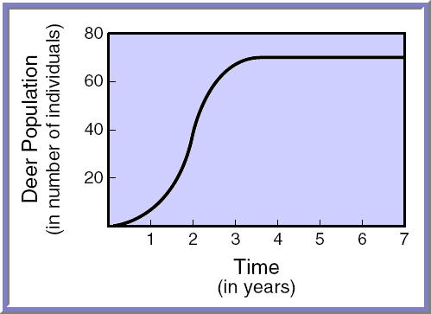
- (2002-48) In the graph above, what is the population of deer at the carrying capacity of the environment?
  - 50
  - 10
  - 70
  - 30

- (2002-24) What is the main cause of fish kills in rivers polluted by fertilizers?
  - Decreased oxygen levels
  - Increased water temperatures
  - Decreased mineral sources
  - Increased water levels
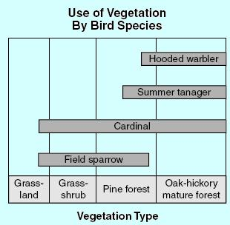
- (2004-14) An experiment is designed to clear an oak-hickory forest and replant the area with pines. Which of the following species would be most threatened by this experiment?
  - Cardinal
  - Summer tanager
  - Hooded warbler
  - Field sparrow

- (2005-33) Wetlands are very specialized ecosystems. Of the following causes of wetland loss, which do people have the least control over?
  - Droughts
  - Draining and filling
  - Discharge of pollutants
  - Overgrazing

- (2006-31) In an aquatic habitat, an example of organisms from the pioneer community would be —
  - grass
  - water lilies
  - water reeds
  - algae

- (2006-15) Animals that are the least specialized generally stand the best chance of survival when the environment suddenly and drastically changes because they are able to:
  - adapt to different conditions
  - move from place to place
  - mutate rapidly
  - reproduce abundantly

- (2002-13) The island of Aldabra lies 400 kilometers off the coast of Africa and is home to the Aldabra Rail, a long-legged wetland bird. The Aldabra Rail is flightless and much different from the rails living on the mainland. This bird became a distinctly different species through —
  - reproductive isolation
  - convergence
  - geographic isolation
  - adaptive radiation
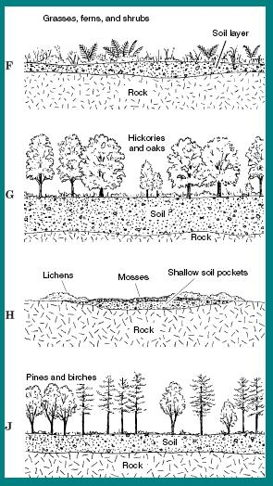
- (2005-18) Each drawing represents different stages in community succession within the state of Virginia. Which of the following drawings represents the climax community in this succession pattern?
  - F
  - G
  - H
  - I

- (2001-12) Wild cats such as cheetahs, lions, and tigers experience decreased genetic diversity as their populations decline and become fragmented due to habitat destruction. Decreased genetic diversity leads to populations with —
  - disproportionate gender ratios
  - increased immigration rates
  - increased birthrates
  - decreased disease resistance

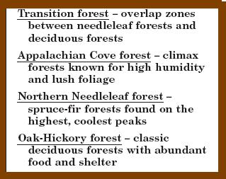
- (2005-12) Shenandoah National Park is home to many different types of ecosystems. According to the characteristics shown above, which ecosystem would most likely be home to a mixture of wildlife species from northern, cooler ranges and southern, warmer ranges?
  - Appalachian Cove forest
  - Oak-Hickory forest
  - Transition forest
  - Northern Needleleaf forest

- (2001-5) In 1893, a one-million acre area of the Grand Canyon National Forest Reserve was home to an estimated 3,000 Rocky Mountain mule deer. Cattle, sheep, and horses also roamed the reserve. In 1906, government hunters killed off hundreds of mountain lions, coyotes, and bobcats when the area was set aside as the Grand Canyon National Game Preserve. The number of Rocky Mountain mule deer rose to over 100,000 by 1923. What was the approximate density of the mule deer in 1923?
  - 1 for every 100 acres
  - 1 for every acre
  - 1 for every 1,000 acres
  - 1 for every 10 acres

- (2002-33) Many of the forests of Virginia have been cleared for farmland. Which of these would least affect the time it would take to return a farm to forest conditions?
  - The ability of the farmland to retain moisture
  - The number of viable tree seeds on the land
  - The density of the original forest on the farm
  - The amount of available nutrients in the soil

- (2003-26) Scientists have noted a decline in fungi species dating back to the early 1900s. Annual crops of edible mushrooms in France and Germany have declined since 1950. One hypothesis to explain this decline is that edible fungi are being overharvested. Global warming and air pollution have also been considered as contributing to the decline. Which of the following would exclude overharvesting as the cause of the decline?
  - Similar declines among edible North American species
  - High fungal numbers in nitrogen-poor
  - A parallel decline in non-edible species
  - Fungal-population increases in tropical regions

- (2003-24) There are probably fewer than 3,000 manatees (Trichechus manatus) left in the world. Which would probably cause the extinction of the species?
  - Increases in the range of the manatees
  - Increases in noncompeting species in the manatees’ habitat
  - Spread of a disease that reduced fertility rates in manatees
  - A sudden freeze in the northern range of the manatees

- (2004-46) Some sphinx moth caterpillars are called tomato hornworms. These large caterpillars do a tremendous amount of damage to tomato plants. Which method of moth control would be most dangerous to the honeybee, which is needed for plant pollination?
  - Using moth scents to attract moths to traps
  - Releasing caterpillar parasites
  - Planting moth-repelling plants
  - Spraying plants with insecticides

- (2004-8) Organisms reproduce following several patterns. Some organisms produce few offspring and provide parental care. Other organisms produce many offspring but provide little or no parental care. Which of the following organisms has the greatest risk of losing a population due to the death of only a few individuals?
  - Bacteria
  - Flies
  - Elephants
  - Rats

- (2001-39) Cleaner fish feed off the algae, fungi, and other microorganisms that are found on larger fish. Other species of fish, which look like the cleaners, are able to approach the larger fish and remove large bites of flesh. If the look-alike populations outnumber the cleaner fish, the —
  - behavior of large fish would change
  - cleaner populations would increase
  - microorganisms on large fish would
  - cleaners and mimics would interbreed

