Name : Science Review checklist
Put a check in the box each time you answer the question correctly |  |  | Cover the right column with a piece of paper or your hand. Answer the question and check your answer. Each time you answer correctly, put a check in the little box. By test time, you'll want a check in each of the boxes. | Cover these answers!
 |  |  | PART ONE – 4TH GRADE SCIENCE
 |  |  | - If you are given a picture and asked to make an OBSERVATION, you must choose the answer that includes only: | things that you can actually see with your own eyes
 |  |  | - Which is NOT an observation I could make while looking up at the sky?  "The sky is blue."  "A big, dark cloud is moving in"  "Soon it's going to rain." | "Soon it's going to rain" is not an observation. It is a prediction.
 |  |  | - The mass of an object is: | the amount of matter in an object
 |  |  | - Given a 2-liter bottle of Coke, 2 liters is a measure of: | the volume of Coke - or how much space it takes up.
 |  |  | - The capacity of a container is how much it can hold. The capacity our large Coke bottle, even if it is empty, is: | 2 liters
 |  |  | - The capacity of an eyedropper would be a few: | milliliters
 |  |  | - A milliliter of liquid is: | a few drops
 |  |  | - The volume of liquid in a graduated cylinder might be 50: | ml or 50 milliliters
 |  |  | - The volume of liquid in a beaker might be 300: | ml or 300 milliliters
 |  |  | - One thousand milliliters equals: | 1 liter
 |  |  | - A liter is close in volume to a: | quart
 |  |  | - .An instrument used to measure mass is a: | balance
 |  |  | - The mass of a paperclip or a sheet of paper is about: | 1 gram or 1g
 |  |  | - The mass of a book could be about: | 1 kilogram or 1kg
 |  |  | - 1000 grams equal: | 1 kilogram
 |  |  | - Length and distance are measured in these metric units: | millimeters (mm) centimeters (cm) (m) kilometers (km)
 |  |  | - Volume of a liquid or capacity of a container is measured in these metric units: | milliliters (mL) liters (L) 1000mL=1L
 |  |  | - Mass is measured in these metric units: | grams(g) 1000g=1kg  kilograms (kg)
 |  |  | - A centimeter is about as long as your: | fingernail
 |  |  | - The length of each of these dashes - - - is about: | 1 or 2 millimeters (mm)
 |  |  | - If your fingernail is one centimeter long, how long is it in millimeters? | 10 (10mm = 1cm)
 |  |  | - The distance from your waist to the floor could be about: | 1 meter or 1m
 |  |  | - One-hundred centimeters equals: | 1 meter
 |  |  | - One thousand meters equals: | 1 kilometer or 1km
 |  |  | - In an experiment to measure the how different types of soil affect tulip growth, you fill five identical pots with different types of soil and place a tulip bulb in each. The variable in the experiment is the: | soil
 |  |  | - The pots, tulip bulbs, water and amount of sunlight are should be the same for all of the pots. These are the: | constants
 |  |  | - For accuracy, you perform the experiment many times. In the first three trials, the tulip in sandy soil grows only 10cm tall before dying. The 4th trial, the tulip grows 15cm tall and flowers. Which result is unusual? | The 4th trial (15cm) because it is different from the others.
 |  |  | - Objects in motion have ______ energy. | kinetic
 |  |  | - Potential energy is ________ energy. | stored
 |  |  | - Due to the pull of gravity, the higher an object is off the ground, the more ____________ it has. | potential energy
 |  |  | - 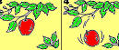When I hold a ball in the air, it has potential energy. When I let go, the ball starts to fall. Potential energy changes to: | kinetic energy
 |  |  | - There are many forms of energy. Energy caused by the movement of electrons is: | electrical energy
 |  |  | - Energy stored in food, batteries and fossil fuels like coal and gasoline is: | chemical energy
 |  |  | - Two objects rubbing together create: | friction
 |  |  | - Friction resists or stops motion, and creates: | heat
 |  |  | - Unless acted on by a force, objects in motion tend to stay in motion and objects at rest remain at rest. This is the principal of: | inertia
 |  |  | - It's harder to push a real truck than a toy truck because objects with more mass have: | more inertia
 |  |  | - Which will light a bulb, an open or closed circuit? | A closed circuit
 |  |  | - 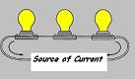If your string of holiday lights goes dark when one little bulb burns out, the string of lights is a: | series circuit
 |  |  | - 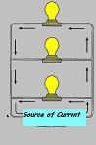This circuit has more than one pathway for the flow of electrical current. If one bulb burns the others will remain lit. It is a: | Parallel circuit
 |  |  | - Electrical energy moves easily through materials that are: | conductors.
 |  |  | - Wires are usual made from ____ because it conducts electricity well. | metal (often copper)
 |  |  | - 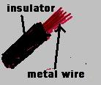Material like rubber, plastic and wood do not conduct electricity well. They are: | insulators
 |  |  | - 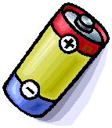This is a dry-cell battery. Common dry-cells usually have low: | voltage (1.5v or 9v)
 |  |  | - Magnets attract these metals: | iron (steel) cobalt, nickel
 |  |  | - 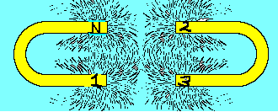The iron filings in this picture show ________created by a magnetic field. | lines of force
 |  |  | - Magnetism and _______ are very closely related. | electricity
 |  |  | - An electric current creates a magnetic field, and a magnetic field creates an _________ . | electric current
 |  |  | - 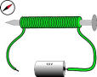If you wrap wire around a nail and run electricity through the wire, you have created an:  Electromagnets are useful because they can be turned on an off. | electromagnet
 |  |  | - If you rub your feet on the carpet, or rub a balloon on a wool sweater, you may create: | static electricity
 |  |  | - Static electricity occurs when negatively charged _____ are rubbed off of one surface and on to another. | electrons
 |  |  | - Benjamin Franklin learned that lightning was a form of electricity. What kind of electricity? | static electricity
 |  |  |  | Thomas Edison
 |  |  | - Which plant part takes in water and nutrients? | the root
 |  |  | - Which part supports the plant and allows the movement of water and nutrients? | the stem
 |  |  | - Which plant part makes food for the plant? | the leaves
 |  |  | - The seed forms in the female reproductive part of the flower called the: | pistil
 |  |  | - Pollen forms on the ends of the male reproductive parts of the flower called the: | stamen
 |  |  | - The small leaves that form around the developing flower are the: | sepals
 |  |  | - Pollen is transferred from the stamen to the pistil in a process called: | pollination
 |  |  | - Most plants reproduce with seeds, but ferns and mosses reproduce with: | spores
 |  |  | - Green plants produce their own food in a process called: | photosynthesis
 |  |  | - To produce food, green plants use: | water, nutrients, sunlight, carbon dioxide (from the air) and chlorophyll.
 |  |  | - Plants are green because of: | chlorophyll
 |  |  | - Many plants enter a period of ______ in the winter, which is similar to hibernation for animals. During this period most of their normal activities stop. | dormancy
 |  |  | - An organism's _____ provides food, water, shelter and space. | habitat
 |  |  | - All of the organisms in a forest make up a _______, and all of the organisms in a pond make up a pond _______. | forest community;  pond community
 |  |  | - All energy comes from _____ , and then cycles through the food webs to all of the animals in the community. | the sun
 |  |  | - . _______ get energy directly from the sun and use it to make food. | Plants
 |  |  | - Because plants produce their own food, they are called ___________ . | producers
 |  |  | - Other organism do not get their energy from the sun. They get their energy by: | eating plants, or eating animals that have eaten plants.
 |  |  | - Organisms that get their energy from eating plants or other animals are called: | consumers
 |  |  | - The sun's energy cycles through the ecosystem in this order: | sun->producers->consumers>decomposers
 |  |  | - 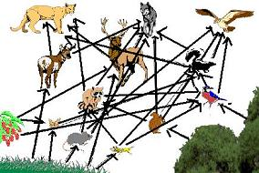All of the interrelated food chains in an ecosystem make up a: | food web
 |  |  | - Food chains and food webs always start with a: | plant
 |  |  | - The food chain starts with a producer (a plant) and ends with a: | decomposer
 |  |  | - Decomposers like ______ break down organisms and recycle them back to the nutrient pool. | fungi
 |  |  | - All of the living and nonliving things in an environment make up: | an ecosystem
 |  |  | - Everything in an ecosystem depends on everything else. Humans often destroy ecosystems by: | polluting ponds, chopping down forests, etc.
 |  |  | - The specific place an organism has in the food web is the organism's: | niche
 |  |  | - The niche of every organism is different, and an organism's niche changes as it grows. A niche is the organism's role in the community, and includes: | what it does, what it eats, and what eats it.
 |  |  | - All organisms have _________ that allow it to survive in its environment. | adaptations
 |  |  | - Structural adaptations are __________ that help an organism survive, like long beaks, webbed feet, camouflage. | body parts
 |  |  | - Behavioral adaptations are things that organisms do to survive. Examples of behavioral adaptations are: | migration, hibernation, instincts, etc
 |  |  | - The measure of the amount of heat energy in the atmosphere is: | temperature
 |  |  | - The amount of moisture in the air is: | humidity
 |  |  | - The weight of the air causes: | air pressure
 |  |  | - Air circulates around the Earth in big chunks called: | air masses
 |  |  | - The boundary between two air masses is called a: | front
 |  |  | - A warm front occurs when a warm air mass pushes out a cold mass. A warm front usually brings: | steady rain or drizzle followed by warmer temperatures.
 |  |  | - A cold front occurs when a cold air mass pushes out a warm air mass. A cold front usually brings: | a short period of heavy rain or thunder, followed by clear colder weather.
 |  |  | - A falling barometer often means: | rainy weather ahead.
 |  |  | - 106. What kind of cloud brings stormy weather, thunderstorms, and sometimes even tornadoes? | Cumulonimbus
 |  |  | - 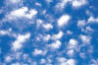Puffy white clouds that look like cotton balls are: | cumulus clouds
 |  |  | - 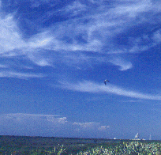High, thin, wispy clouds are: | cirrus clouds
 |  |  | - 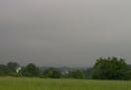Which cloud forms a gray blanket over the sky, often bringing steady rain or drizzle? | stratus cloud
 |  |  | - This instrument measures air pressure is a: | barometer
 |  |  | - This instrument measures wind speed: | anemometer
 |  |  | - This instrument measures precipitation: | rain gauge
 |  |  | - These severe storms usually form over water in the Caribbean: | hurricanes
 |  |  | - Earth is one of ____ planets that revolve around the sun. | 8
 |  |  | - Earth is the ______ planet from the sun. | third
 |  |  | - Venus, Mercury, Earth and Mars are the : | rocky inner planets
 |  |  | - The gas giants are: | Jupiter, Saturn, Uranus, and Neptune
 |  |  | - The smallest planet is: | Mercury
 |  |  | - The largest planet is: | Jupiter
 |  |  | - The planets listed from closest to farthest from the sun: | Mercury, Venus, Earth, Mars, Jupiter, Saturn, Uranus, Neptune
 |  |  | - Because of its small size and irregular orbit, Pluto is now considered a: | dwarf planet
 |  |  | - Earth revolves around the sun in: | 365 days (one year)
 |  |  | - The moon revolves around the Earth in approximately: | one month
 |  |  | - Seasons are caused by the: | the tilt of the Earth as it revolves around sun
 |  |  | - This is a _____ _ moon. | gibbous
 |  |  | - This is a ______ moon. | crescent
 |  |  | - The moon can’t be seen when it passes between the Earth and the sun because the illuminated side faces away from Earth. This phase is called: | a new moon
 |  |  | - How far is the Earth from the sun? | 150 million km
 |  |  | - What does the Earth have that allows it to support life? | water and an oxygen rich atmosphere
 |  |  | - How does the Earth's atmosphere protect the Earth? | It blocks out most of the sun's damaging rays.
 |  |  | - Ancient Greeks like Aristotle and Ptolemy believed _________ was the center of our solar system, and the planets and the sun revolved around us. | the Earth
 |  |  | - Copernicus and Galileo tried to convince the world that ________ was actually the center of the solar system, and all of the planets revolve around it, and not around the Earth. | the sun
 |  |  | - Galileo used his invention of the _________ to observe the sky. | telescope
 |  |  | - The NASA Apollo missions sent astronauts to the ______ . | the moon
 |  |  | - About half of Virginia is considered to be in the Chesapeake Bay ________ because the surface water and all of the materials it carries drain into the Chesapeake Bay. | watershed
 |  |  | - Land drained by rivers west of Roanoke is part of the Mississippi / Gulf of Mexico:___________. | watershed
 |  |  | - Much of Virginia is covered in ______, an important natural resource for Virginia. | forests
 |  |  | - An important energy resource mined in the southwestern part of Virginia is ________ . | coal
 |  |  | PART 2 – GRADE 5 SCIENCE REVIEW
 |  |  | - Sound is a form of energy produced by: | vibrating matter
 |  |  | - Sound travels in: | waves
 |  |  | 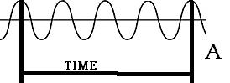  - The ______ of a sound is the number of vibration in a given time. | frequency
 |  |  | - An object vibrating faster will have a higher frequency and a higher: | pitch
 |  |  | 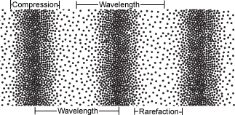  - Sound is a ______ wave. | compression
 |  |  | 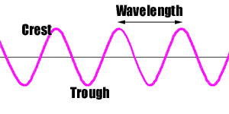  - The distance between compressions, or between the peaks of two waves is the: | wavelength
 |  |  | - What kind of matter does sound travel through fastest? | solids
 |  |  | - Sound travels slower through gases than through liquids and solids because the molecules in gases are: | farthest apart
 |  |  | - Dogs, bats and other animals can hear ________ sounds that humans cannot hear. Whales can hear lower frequency sounds. | high frequency
 |  |  | - Musical instruments _____ to produce sounds. | vibrate
 |  |  | 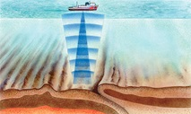  - An instrument that uses sound echoes to measure see the ocean floor or underwater objects is a: | sonar
 |  |  | - _______ is a combination of several different wavelengths of light traveling together. | white light
 |  |  | - The wavelengths of light from longest to shortest are. | red, orange, yellow, green, blue, violet
 |  |  | - The color light with the longest wavelength is: | red
 |  |  | - The color light with the shortest wavelength is: | violet
 |  |  | - Light travels much _____ than sound through the atmosphere. | faster
 |  |  | - It takes light from the sun _______ to travel 150 million km to Earth. | 81/2 minutes
 |  |  | - Light travels in straight paths called: | rays
 |  |  | - Light travels fastest through: | a vacuum or empty space
 |  |  | 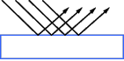  - When light bounces off an object, it is: | reflected
 |  |  | 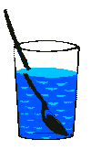  - When light bends, it is: | refracted
 |  |  | - When light passes through an object, it is: | transmitted
 |  |  | - Light passes easily through a window because the glass is: | transparent
 |  |  | - Some light can pass through wax paper. Wax paper is: | translucent
 |  |  | - Light can't travel through a wall. A wall is: | opaque
 |  |  | 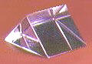  - When white light passes through a ________ , the different wavelengths bend at different angles, so we see a rainbow of colors. | prism
 |  |  | - There are over 100 pure substances, called: | elements
 |  |  | 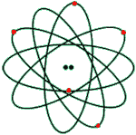  - The smallest part of an element is an: | atom
 |  |  | - When two of more elements combine to make a completely new substance, it is called a: | compound
 |  |  | - The smallest part of compound is a: | molecule
 |  |  | - H₂O is a compound known as: | water
 |  |  | - NaCl (Sodium Chloride) is a compound called: | salt
 |  |  | - Substances that combined but can be separated again are called: | mixtures
 |  |  | - A mixture in which one substance dissolves in another is called a: | solution
 |  |  | - Sugar mixed into water is a_______ because if the water evaporated, the sugar would remain in the container. | solution (a type of mixture)
 |  |  | - The three states of matter are: | solid, liquid, and gas
 |  |  | - If you heat a solid, it may: | melt into a liquid
 |  |  | - If you heat a liquid, it may: | evaporate into a gas
 |  |  | - If you cool a liquid, it may ______ into a solid. | freeze
 |  |  | - When you heat matter, the atoms and molecules: | move faster and usually spread apart
 |  |  | 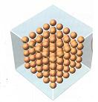  - In a solid, the molecules are: | tightly packed and barely moving
 |  |  | 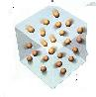  - In a gas the molecules are: | moving fast and spread apart
 |  |  | - Living things are made of: | cells
 |  |  | - Using a ______ you can see many parts of a cell. | microscope
 |  |  | - Plant cells tend to be: | rectangular
 |  |  | - 49. The control center of the cell is the: | nucleus
 |  |  | - 50. The jellylike substance in a cell is the: | cytoplasm
 |  |  | - The water and waste storage sacs in a cell are called: | vacuoles
 |  |  | - The outer layer of an animal cell is the: | cell membrane
 |  |  | - Plant cell have cell membranes but they have another stiff outer layer called the: | cell wall
 |  |  | - Plants cell also have _____ which hold chlorophyll needed for photosynthesis. | chloroplasts
 |  |  | - Which is the plant cell? Why?  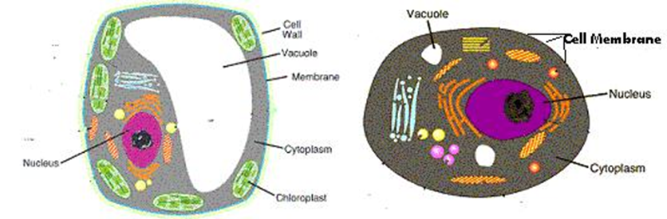 | One on left – it has a cell wall, chloroplasts and large central vacuole
 |  |  | - Are most plants vascular or nonvascular? | Vascular
 |  |  | - Plants that do not have special veins to transport food and water are: | nonvascular
 |  |  | - Name a nonvascular plant. | moss
 |  |  | - Animals with backbones are: | vertebrates
 |  |  | - Animals without backbones are: | invertebrates
 |  |  | - Snakes, lizards and fish are: | vertebrates
 |  |  | - clams, squid, worms and insects are: | invertebrates
 |  |  | - The ocean covers how much of the Earth? | 70%
 |  |  | - The shallow parts of the ocean floor at the edges of the continents make up the: | continental shelf
 |  |  | - The salinity of the ocean varies. Salinity means: | saltiness
 |  |  | - Wind patterns and different water densities cause: | ocean currents
 |  |  | - As the depth of the ocean increases, what else increases? | water pressure
 |  |  | - As the depth of the ocean increases, what decreases? | temperature and the amount of light
 |  |  | - An ocean current which carries warm water from the equator to Europe is: | The Gulf Stream
 |  |  | - The greatest variety of ocean life is in the shallowest part of the ocean, above the: | continental shelf
 |  |  | - These tiny plant-like organisms produce much of the Earth's oxygen and serve as the basis of the ocean ecosystem | Phytoplankton
 |  |  | - Phytoplankton, like other plants, need sunlight for photosynthesis, and therefore live : | On the ocean's surface
 |  |  | - The deepest parts of the ocean are: | trenches
 |  |  | - Underwater mountains caused by plate movements are: | mid-ocean ridges
 |  |  | - Three types of rock are: | sedimentary, metamorphic, and igneous
 |  |  | - Over a period of time, layers of sediment are pressed together to form these types of rocks. | Sedimentary
 |  |  | - When molten rock or magma cools below the Earth's surface or cools after erupting from a volcano as lava, this type of rock is formed. | Igneous rock
 |  |  | - Rocks formed from other types of rocks by intense heat and pressure deep within the Earth are called: | Metamorphic rocks
 |  |  | - Sedimentary rocks often contain these remains of organisms which tell us a lot about life and Earth in the past. | fossils
 |  |  | - Scientific evidence indicates the Earth is how old? | 4.6 billion years old
 |  |  | - The Earth's surface is constantly changing due to heat and pressure within the Earth and weathering and erosion at the surface. These processes constantly change rock from one type to another in a cycle called: | The Rock Cycle
 |  |  | - The two layers of the Earth that are composed mostly of rocky material are: | The crust and mantle
 |  |  | - The layers composed mostly of iron and nickel | Inner and outer core
 |  |  | - Heat energy causes movement of material within the Earth. Large, continent-sized blocks that move slowly about the Earth's surface due to this heat energy are called: | plates
 |  |  | - Most earthquakes and volcanoes are located at the boundary of the plates, called: | faults
 |  |  | - Mountain ranges, including the Appalachian mountains, mid-ocean ridges and trenches are caused by: | Plate movements
 |  |  | - Rocks on the Earth's surface are constantly being broken down by chemical processes, weather, glaciers and even tree roots. Rocks are broken into smaller pieces in a process called: | weathering
 |  |  | - Weather rock material, sand and soil can be moved by water and wind in a process called: | erosion
 |  |  | - Roots hold soil in place. How can soil erosion be prevented? | planting trees and other vegetation
 |  |  | - Mountains are usually caused by: | plate movements
 |  |  | - Mountains and volcanoes usually form on the _____ between two plates, when the plates push together or split apart. (convergent and divergent boundaries) | boundaries
 |  |  | - Plates that slide against each other are called sliding boundaries - They cause: | earthquakes

