Released SOL Test Questions
2002-2012
Sorted by Topic
Compiled by SOLpass – www.solpass.org

5.5 Living Systems
The student will investigate and understand that organisms are made of one or more cells and have distinguishing characteristics that play a vital role in the organism’s ability to survive and thrive in its environment. Key concepts include
- basic cell structures and functions;
- classification of organisms using physical characteristics, body structures, and behavior of the organism; and
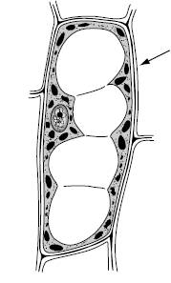
- traits of organisms that allow them to survive in their environment.

CELLS
- Which of these organisms has cells with cell walls?
(2011 test – question 32)
- A bluebird
- A pine tree
- A ladybug
- A fox squirrel
- Which structure does a plant cell have that an animal cell does not have?
(2010 test – question 9)
- Vacuole
- Cytoplasm
- Cell membrane
- Cell wall
- Which structure surrounds and protects an animal cell?
(2009-11)
- Nucleus
- Vacuole
- Cytoplasm
- Cell membrane
- Which part of a plant cell is responsible for controlling the activities of the other parts of the cell?
(2008 test – question 30)
- Vacuole
- Nucleus
- Cell wall
- Chloroplast
- Which of these is the main function of a cell wall?
(2008-31)
- To make food
- To store water
- To provide support
- To make the plant green
- Which of these cells most likely came from a plant?
(2007-40)
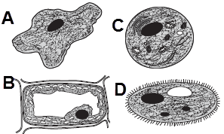
- What part of the plant cell is shown at the arrow?
(2002 test – question 3)
- Cell wall
- Cell membrane
- Vacuole
- Nucleus

- The part of a plant cell that gives the cell its green color is the —
2004 test – question 31)
- nucleus
- cytoplasm
- vacuole
- chloroplast
- The internal parts of a cell are suspended in a jelly-like liquid called the —
(2001 test – question 23)
- nucleus
- cell membrane
- cytoplasm
- chloroplasts
VASCULAR / NONVASCULAR
- A student sees many plants around a pond. The student can determine which plants are nonvascular by —
(2007-38)
- observing if they lack true stems, roots, or leaves
- examining the plants for spores
- counting the number of leaves on each stalk
- noticing if the plants are near rocks

- Trees, wild flowers, and grasses are all considered to be
(2004-34)
- vascular plants
- nonvascular plants
- woody plants
- nonwoody plants
- Moss is best classified as —
(2010-36)
- a type of mold
- an evergreen plant
- a species of fungus
- a nonvascular plant
- Which of these plants does not have special tissues to deliver food and water to its cells?
(2005-20)
- Maple
- Dogwood
- Tomato
- Liverwort
- Which of the following plants is an example of a nonvascular plant?
(2002-20)
- Dogwood
- Moss
- Ginkgo
- Pine tree
- Redwood trees can grow to be very tall. They can grow so tall because they are —
(2003-27)
- vascular
- deciduous
- nonvascular
- flowering
VERTEBRATES/ INVERTEBRATES
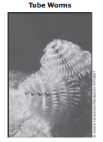
- Which of these would best describe the tube worms shown?
(2011 test – question 39)
- Mammals
- Vertebrates
- Amphibians
- Invertebrates
- Which of the following animals is an invertebrate?
(2007 test – question 21)
- Squirrel
- Sea gull
- Cricket
- Lizard
- Which of these animals is an invertebrate?
(2008 test – question 24)
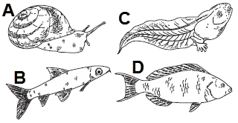
- Which of the following is an invertebrate?
(2002 test – question 29)
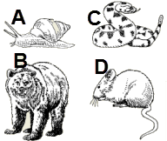
- Which of the following would be classified as a vertebrate?
(2005 test – question 33)
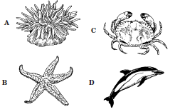
- How is a fish different from a jellyfish?
(2004 test – question 4)
- A fish has a backbone.
- A fish is in the animal kingdom.
- A fish can reproduce.
- A fish lives in water.
- Which of the following sea animals would be classified as an invertebrate?
2003 test – question 28)
- Sea horse
- Squid
- Shark
- Seal
- The jellyfish is an invertebrate because it lacks —
(2001 test – question 2)
- eyes
- bones
- blood
- cells
- In which chart are all the organisms sorted correctly?
(2010 test – question 29)

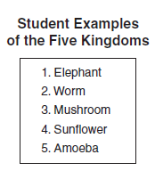
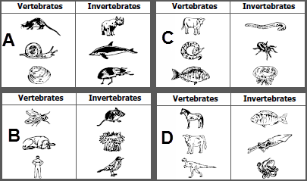
- A student made a list of examples of each of the five kingdoms. The list contains two examples from the same kingdom. Which one of these should be removed from the list?
(2007 test – question 6)
- Worm
- Mushroom
- Sunflower
- Amoeba
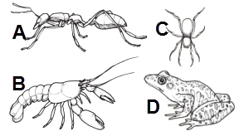
- Which of these animals has a different body support system than the others?
(2009 test – question 37)

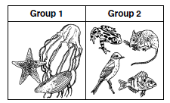
- Which animal belongs in group one?
(2006 test – question 5)

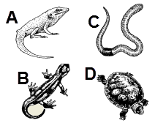
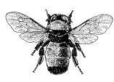
- The picture shows a bumblebee. Which part of the bumblebee is most helpful in identifying it as an insect?
(2005 test – question 30)
- Shape of eyes
- Number of legs
- Presence of wings
- Location of antenna
NOTE – the 2010 VDOE Curriculum Framework no longer mentions the five kingdoms, so questions like the following will presumably no longer be included on the 5th grade test.
- A kingdom is the largest classification of living things. What other organisms, besides plants and animals, make up the five kingdoms?
(2006 test – question 7)
- Fungi, protists, and monerans
- Fungi, protists, and viruses
- Monerans, protists, and viruses
- Monerans, protists, and vertebrates
- The picture shows a Venus’s flytrap.
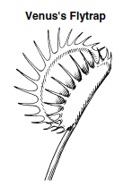
This unusual organism can trap flies with its leaves, but it gets most of its food from photosynthesis. To what kingdom does this organism belong?
(2003 test – question 18)
- Monera
- Protista
- Fungi
- Plantae
- The American dogwood is a member of which kingdom of living things?
(2002 test – question 36)
- Monera
- Animal
- Protist
- Plant
- Although the mushroom looks like a plant, it is in a different kingdom. The main difference between the fungi kingdom and the plant kingdom is that fungi —
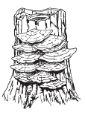
(2008 test – question 23)
- Use chlorophyll to make sugar
- have special tissues
- absorb nutrients from other organisms
- depend on the Sun for energy
- Which of these belong to the kingdom Monera?
(2001 test – question 16)
- Ferns
- Mosses
- Mushrooms
- Bacteria

