NAME________________________
SOL 4.5

Habitats, Niches and Adaptations

POPULATION – A group of the same species living in the same place at the same time.

COMMUNITY-- All of the populations that live in the same area

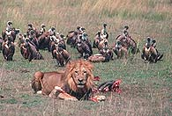
- The animals above are part of a :
  - grassland population
  - grassland community

- A community is:
  - all of the animals living in an area.
  - all of the animals of one species in an area.

- A population is:
  - all of the animals in a particular area.
  - all of ONE KIND of animal in an area.

- An example of a population is:
  - all the animals in a barnyard
  - all the rabbits living in a meadow
  - all the alligators in the world
  - a squirrel family in its nest

- Which sentence is the best description of a community?
  - A community provides shelter for one type of organism
  - A community is made up of all types of organisms in an area
  - A community is made up of one type of organism
  - A community provides food for only
one type of organism

- Which of the following is not a basic need of all animals
  - food
  - friends
  - water
  - protection from predators

- An ecosystem is:
  - the populations and the nonliving parts of an environment that interact with each other
  - the non-living surroundings
  - the living surroundings only

- When an animal’s environment changes, the animal can:
  - migrate
  - adapt
  - either migrate, adapt

- A _____ is an animal’s surroundings, where it lives, and on which it depends for all of its needs.
  - habitat
  - village
  - community
  - population

ADAPTATIONS
Almost every part of an animal can be considered an adaptation. Adaptations allow animals to survive in their environment.
There are two kinds of adaptations. STRUCTURAL ADAPTATIONS are body parts or body features, i.e. a pointed bill or feathers. BEHAVIORAL ADAPTATIONS have to do with, you guessed it, behavior. Behavioral adaptations are the things animals do to help them survive and compete in their environment. Some of these behaviors may be INSTINCT, and some may be LEARNED.

- An animal’s ____ allow it to survive in its environment.
  - community
  - adaptations
  - friends

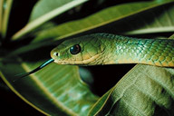_
- What is this adaptation called?
  - camouflage
  - mimicry
Circle : Behavioral or Structural adaptation

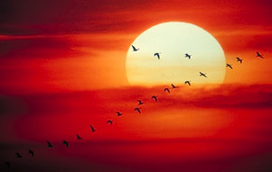
- The adaptation shown above helps birds and many other animals survive winter. It is called __________
Circle: Behavioral or Structural

- When an animal looks like another animal to trick its enemies, this is called:
  - hibernation
  - mimicry
  - migration
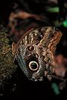
- It would be easy to mistake this butterfly’s wing for a more threatening animal. This is an example of:
  - camouflage
  - mimicry
Circle: Behavioral or Structural

- The strong scent of the skunk serves what basic need?
  - defense
  - camouflage
  - shelter
Circle: Behavioral or Structural adaptation

- Why do birds have differing bills?
  - So they look better
  - Their bills are adaptations that make them better suited to the food in their environments.

- When winter arrives, some animals enter a deep sleep called:
  - migration
  - hibernation
Circle: Structural or Behavioral adaptation?

- Building a web is:
  - a learned behavior
  - an instinct
Circle: Structural or Behavioral adaptation?

- Which is an example of a learned behavior?
  - bees looking for flowers
  - ducks migrating in the spring and fall
  - a fish swimming
  - a dog sitting on command

- If disease kills all the rabbits in an environment, foxes may choose a different food source. This is an example of:
  - a behavioral adaptation
  - a life cycle
  - a structural adaptation
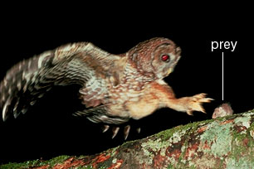

- The mouse above is the prey and the owl is the: (write the answer)
______________________predator___
- The color of a fish, its shape, its size, the structure of its gills and the way it acts, are all examples of the fish’s:
  - niche
  - instincts
  - behaviors
  - adaptations

Each organism has a specific role in its community. This role is the organism's NICHE. An animal’s niche may change many times as it grows.

- The easiest way to understand an animal’s niche, is to consider:
  - what it eats, and what eats it.
  - what it looks like
  - where it lives
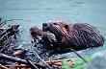
- This picture tells us something about the beaver's:
  - niche
  - population

- An animal’s niche can be thought of as its place in the food chain. Does an animal’s niche stay the same throughout its life?
  - yes
  - no

FOOD CHAINS
consumers
herbivores producers
decomposer bacteria
sunlight energy
second photosynthesis
carnivore omnivores

Animals eat plants or other organisms for _____________. Plants use ___________ to make their own food through a process called ___________. This is why plants are called __________ .
Plants store energy they don’t need in roots, stems, and leaves. This energy is passed on to animals that eat plants. Animals that eat plants are called ___________. Plants are first in any food chain, and herbivores or __________, Animals that eat both meat and plants, are __________. Can a carnivore follow a plant in a food chain? Yes/No
Next in the food chain comes the animal that eats the herbivore. This is the _________ .
Herbivores and carnivores are _________, not producers, because they consume other organisms for food. They do not make their own food using sunlight.
A food chain can be short or long, but it ends with a ____________. Mushrooms and ___________ are examples of decomposers. Decomposers break down dead organisms into nutrients needed by the plants at the beginning of the food chain.

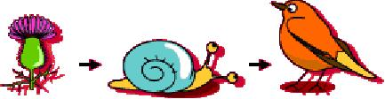
- Is this food chain in the right order?
a. yes
b. no

- Which is the herbivore?
a. the bird
b. the snail
c. the flower

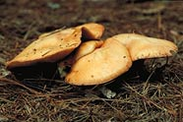
- These mushrooms are:
  - plants (producers)
  - consumers
  - decomposers

Fill in the missing link in these food chains with one of the following (bear, skunk, eagle, mouse, cow, grass) or an organism of your choice.

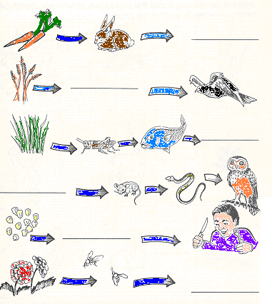
- What is first in every food chain?
a. a producer
b .a consumer
c. a herbivore
d. a carnivore

- At the very end of the food chain is the:
  - carnivores
  - producers
  - decomposer

Label each part of the food chain producer, herbivore, carnivore or omnivore
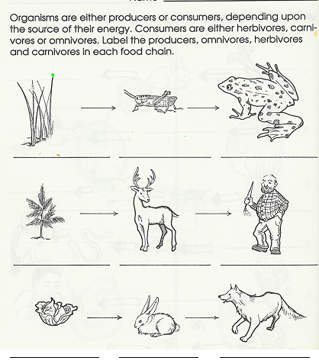

- When plants and animals die, _____ break down the living matter so it can be used again in other ways.
- decomposers
- carnivores
- spiders

- Some examples of decomposers are:
- mushrooms
- fungus
- bacteria
- all of the above

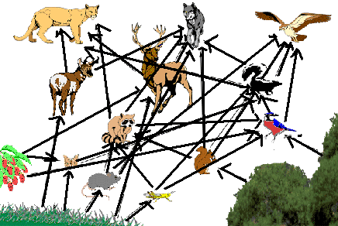

- This is a:
a. food chain
b. food web
c. web of food

- A producer that's part of this food web is:
a. the mouse
b. the grass
c .the skunk

- One of the many food chains that make up the web is:
a. squirrel—raccoon--oak tree-- mountain lion
b. oak tree—squirrel—raccoon-- mountain lion
c. wolf—raccoon—mouse-- grass
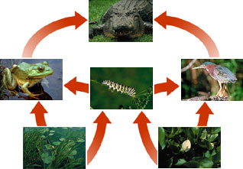
- What effect might a disease among the alligator population have?
- The number of frogs would decrease
- The number of caterpillars might increase
- no effect
- The number of frogs might grow until there weren't enough caterpillars for them to live on.

- If the caterpillars all died from chemical pollution, what effect would this have on the food web?
- the number of frogs would increase
- the number of alligators would increase
- the number of frogs and alligators might decrease unless the frogs found something else to eat.
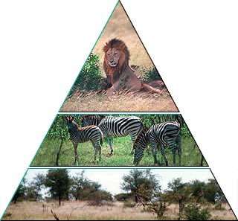

- The picture above is called:
- a food web
- an energy pyramid

- What is at the base of the pyramid?
- Producers (plants) are at the bottom because they use the sun's energy to make their own food.
- Carnivores are at the base because they are bigger and stronger.

- At the top of the pyramid are:
- carnivores
- herbivores
- all consumers

- What would happen if, on an island, a disease killed most of the plants?
- Animals would adapt and eat meat
- Nothing would happen
- Soon there would be no life on the island. Herbivores would starve first; carnivores would follow.

- If one link in a food chain disappears, -
a. other organisms are not affected.
b all of the other organisms are affected.

