**5th Grade Released Test Questions** on **Scientific Process and Measurement** SOL 4.1 & SOL 5.1

Compiled by [www.solpass.org](http://www.solpass.org)

Questions are taken from 2000-2011 released tests and organized by topic. The year and question number precede each question.

Measurement - Q1-43

Scientific Process Q44-69

Classification Q70-80

Data, Tables and Graphs Q81-120

Measurement – Length

1. (2000-3) The length of an adult human footprint would be closest to 20
2. millimeters
3. centimeters
4. meters
5. decameters

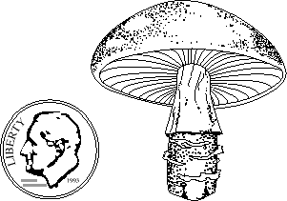

1. (2000-10) About how tall is this mushroom?
2. 1 kilometer
3. 4 centimeters
4. 3 meters
5. 10 millimeters



1. (2001-18) The picture shows a magnified view of a tick on a penny. About how long is the tick?
2. 1 millimeter
3. 2 kilometers
4. 4 meters
5. 10 centimeters 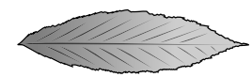
6. 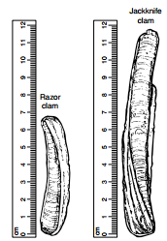(2010-23) According to the picture, which measurement best identifies the length of the leaf?
7. 5.0 cm
8. 6.0 cm
9. 6.5 cm
10. 7.0 cm

1. (2010-8) About how much longer is the jackknife clam than the razor clam?
2. 5 centimeters
3. 7 centimeters
4. 10 centimeters
5. 12 centimeters

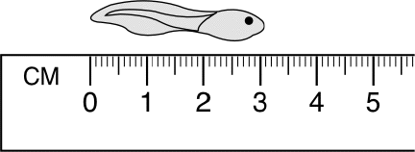

1. (2002-35) What is the length of the tadpole?
2. 2.8 cm
3. 3.1 cm
4. .5 cm
5. 0 cm

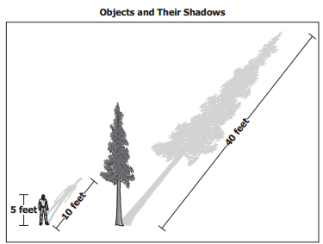

1. (2011-40) Based on information in the diagram, about how tall is the tree?
2. 10 feet
3. 20 feet
4. 40 feet
5. 80 feet

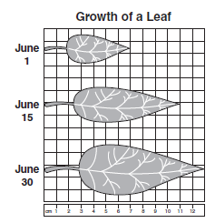

1. (2007-8) Three measurements of the same leaf were taken during June. Based on the graph, how much did the leaf grow in length from June 1 to June 30?
2. 6 cm
3. 7 cm
4. 11 cm
5. 13 cm

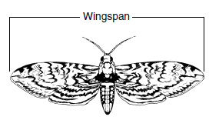

1. (2006-24) The wingspan of this moth is about —
2. 7 mm
3. 8 mm
4. 7 cm
5. 8 cm

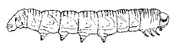

1. (2000-4) What is the length of this caterpillar?
2. 6.0 cm
3. 6.5 cm
4. 7.0 cm
5. 7.5 cm
6. (2006-33) By August, a student noticed that the sunflowers outside his house were as tall as the back door of his house. About how tall were the sunflowers?
7. 0.2 meters
8. 2 meters
9. 20 meters
10. 200 meters
11. (2004-11) Over the period of one year, a rock wall shifted 15 millimeters. Which of these lines best shows the distance the wall moved? (b)

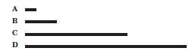

MEASUREMENT - LIQUID Volume

1. 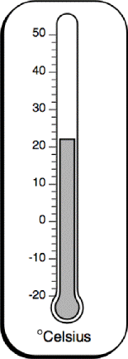(2004-6) The picture shows a thermometer in a room. What is the temperature of this room?
2. 19°C
3. 20°C
4. 21°C
5. 22°C

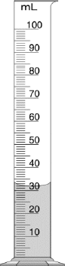

1. (2004-19)(2003-16) If 5 milliliters of vinegar are added to the water in the cylinder, what will be the total volume of the liquid?
2. 30 milliliters
3. 27 milliliters
4. 37 milliliters
5. 35 milliliters
6. 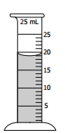(2010-35) Students filled a graduated cylinder with the amount of water shown. How much more water needs to be added to the cylinder to measure 25 mL?
7. 2 mL
8. 4 mL
9. 6 mL
10. 9 mL

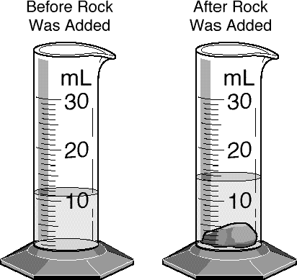

1. (2000-8) What is the difference between the water level in the cylinder before and after the rock was added?
2. 3 mL
3. 11 mL
4. 14 mL
5. 25 mL

MEASUREMENT – MASS

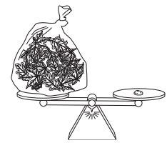

1. (2009-1) Based on the picture, the bag of leaves has —
2. less mass than the pebble
3. the same mass as the pebble
4. the same volume as the pebble
5. less volume than the pebble

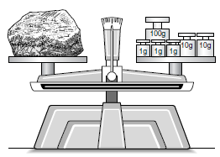

1. (2006-19) Which of these is the most accurate reading of the mass of the rock on the balance scale pictured?
2. 33 g
3. 120.3 g
4. 123 g
5. 303 g

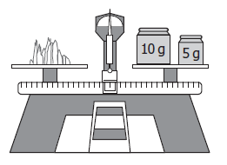

1. (2008-15) What is the mass of this mineral?
2. 5 grams
3. 10 grams
4. 15 grams
5. 20 grams
6. (2005-7) Which of the following measurements is most likely the mass of a pencil?
7. 10 centimeters
8. 17 kilograms
9. 17 millimeters
10. 10 grams

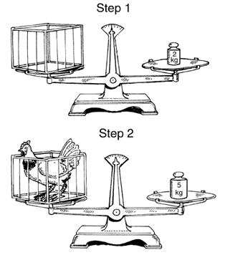

1. (2001-19) Amanda studied the mass gain in chickens for her science project. Which of these is the mass of this chicken?
2. 2 kg
3. 3 kg
4. 5 kg
5. 7 kg
6. (2003-37)Which item below would have a mass closest to that of a thumbtack? ( c )

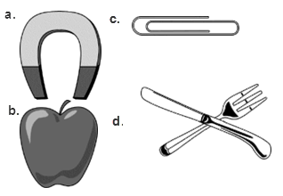

MEASUREMENT – Units

1. (2010-39) The distance between Richmond and Norfolk is best measured in —
2. kilometers
3. meters
4. centimeters
5. millimeters
6. (2009-19) Which unit is best to use for measuring the width of oak tree leaves?
7. Centimeter
8. Gram
9. Kilometer
10. Milliliter

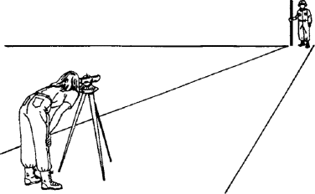

1. (2003-38) This surveyor is measuring the distance of a road. The most appropriate units to measure this distance are -
2. millimeters
3. centimeters
4. decimeters
5. meters
6. (2004-38) During a study of the human body, students are asked to observe the back of their hands and record their observations. What units would be most appropriate for measuring the width of their hands?
7. Grams
8. Centimeters
9. Liters
10. Meters
11. (2002-9) Students must conduct an experiment in which they find out how long a rubber ball bounces before it comes to a stop. Which unit would be best for recording this information?
12. Gram
13. Degrees Celsius
14. Meter
15. Second
16. (2002-1) The capacity of an automobile gasoline tank would most likely be measured in -
17. degrees Celsius (°C)
18. grams (g)
19. liters (l)
20. meters (m)
21. (2005-19) The height of a tree would best be measured in —
22. liters
23. meters
24. grams
25. Celsius
26. (2001-33) Which of these units would be best to use to measure the amount of water in a test tube?
27. Milliliters
28. Meters
29. Kilograms
30. Seconds
31. (2008-11) Students collect pond water in their beakers. Which is the best unit of measurement for the volume of water they collect?
32. Grams
33. Meters
34. Milliliters
35. Centimeters

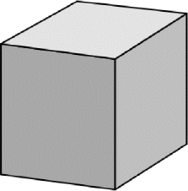MEASUREMENT - INSTRUMENTS

1. (2004-6) Which tools would be needed to measure the size and the mass of a block of wood?
2. A watch with a second hand and a ruler
3. A graduated cylinder and a thermometer
4. A ruler and a balance
5. A thermometer and a meter stick
6. (2010-40) Which tools are best used to determine the speed of a turtle as it walks along a path?
7. Meter stick and graduated cylinder
8. Stopwatch and meter stick
9. Balance and metric ruler
10. Balance and stopwatch
11. (2001-21) Which of these is needed to measure the mass of a rock?
12. An anemometer
13. A barometer
14. A balance
15. A metric ruler
16. (2009-33) What tool is used to determine the mass of an object?
17. Balance
18. Meter stick
19. Thermometer
20. Graduated cylinder
21. (2011-36) Which is the best tool for measuring the temperature of lake water?
22. Meter stick
23. Balance
24. Graduated cylinder
25. Thermometer
26. (2000-5) Which of these should be used to accurately measure 250 mL of water? ( c )

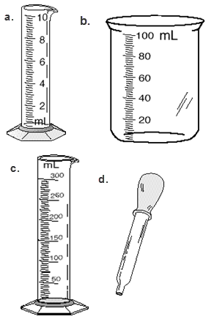

1. (2005-11) Which of these would be the *best* tool to measure the volume of water absorbed by a sponge? ( c )

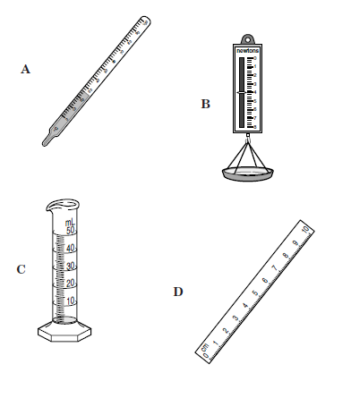

1. (2011-14) A student wants to compare the masses and volumes of three marbles. Which two instruments should be used?
2. Balance and graduated cylinder
3. Centimeter ruler and thermometer
4. Graduated cylinder and centimeter ruler
5. Thermometer and balance
6. (2002-39) Which of the following instruments is used to measure mass? (d)

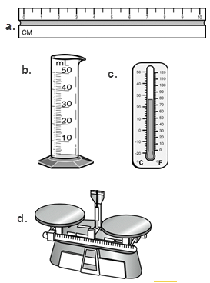

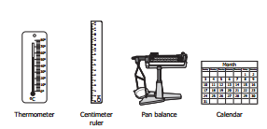

1. (2009-35) Juan is doing an experiment to see how long it takes an acorn to grow into a 0.5-meter-tall oak tree. Which two instruments should he choose?
2. Thermometer and centimeter ruler
3. Thermometer and calendar
4. Centimeter ruler and pan balance
5. Centimeter ruler and calendar
6. (2005-27) Which of these would be used to measure the mass of a marble? (a)

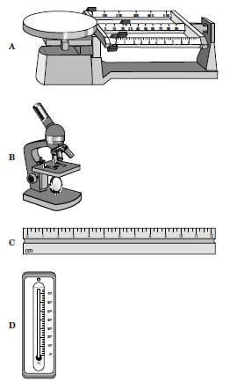

1. (2008-18)Which of these is the best tool to use when measuring the water depth at the edge of a pond? (b)

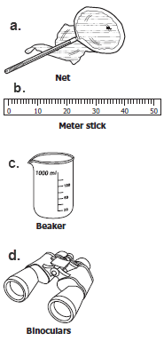

Scientific Process

1. (2009-37) A group of students tested the effects of different amounts of water on ivy plant growth. Afterwards, they could not remember how much each plant grew per day. What should they have done to practice good science? (data)
2. Discuss their observations with other groups in their class.
3. Conduct the experiment with more than one type of plant.
4. Record daily information in a data table.
5. Make up explanations for the results.
6. 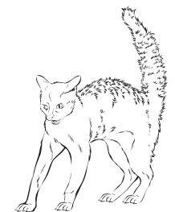(2011-2) According to the picture, which of these is an inference rather than an observation?
7. This animal has hair.
8. This animal has a tail.
9. This animal is arching its back.
10. This animal is frightened.
11. 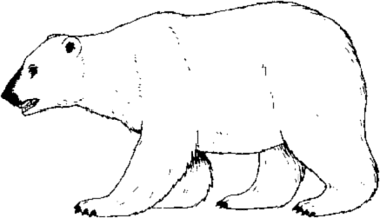(2000-1) Which of these is a conclusion rather than an observation?
12. This bear lives in a cold climate.
13. This bear has big teeth.
14. This bear has black claws.
15. This bear has small ears and eyes.
16. 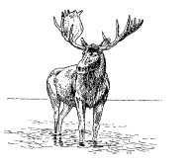 (2005-5) Based on the picture above, which of these is a conclusion rather than an observation?
17. This animal has hair.
18. This animal is standing.
19. This animal has four legs.
20. This animal is a mammal.
21. (2003-29) Which of these can be observed in this picture?

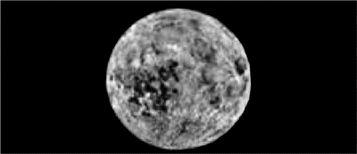

* 1. The moon is circular.
  2. The moon spins around on its axis.
  3. The moon is solid rock.
  4. The moon has little air.

1. (2007-39) Which of the following is an observation about grasshoppers that a science class could have made on their nature walk?
2. The grasshoppers will live longest in a container filled with plants.
3. The grasshoppers are green with long back legs and antennae.
4. The grasshoppers will probably eat more grass than tree leaves.
5. The grasshoppers all hatched from eggs laid the year before.
6. (2008-34) Students notice that in the fall leaves of sugar maple trees turn red, but the leaves of black oak trees turn brown. The students are making —
7. an observation
8. a conclusion
9. a prediction
10. an inference
11. (2007-18) A group of students was preparing an activity to determine whether certain materials will float or sink when placed on water. Before the experiment started, one student said, “I think the sponge will float.” This statement was —
12. a conclusion
13. a fact
14. an observation
15. a prediction
16. 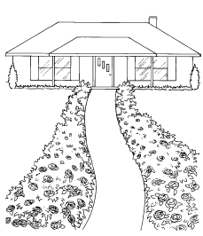 (2002-4) Sandy grows roses along her walkway. The roses close to the street had more blooms than the roses close to the house. Which statement is a hypothesis Sandy could make about her roses?
17. There were many blooms on the roses near the house and fewer blooms on the roses closest to the street.
18. The roses closest to the street had more blooms because they received more sunlight.
19. The roses near the house were taller but had fewer blooms.
20. The roses close to the house had fewer blooms and leaves.
21. (2010-13) Max is doing an experiment on tomato plants. His hypothesis is, “A tomato plant will not grow in a shady area.” On which of these relationships did Max base his hypothesis?
22. Warm temperature causes plant growth.
23. Sunlight causes plant growth.
24. Tall plants cause shade.
25. New plants need fresh water.

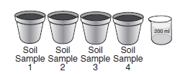

1. (2007-29) To find out which soil absorbs (holds) moisture best, each container shown must — (variables/constants)
2. be made of a different material
3. have soil from the same place
4. be tested by the same person
5. contain the same amount of soil
6. (2003-13) Two students wanted to find out which of their toy race cars would go the farthest. They let each car roll down a ramp and then measured how far the cars rolled. Which of these should be held constant if they want a fair test of their cars?
7. The height of the ramp
8. The weight of the ramp
9. The length of the cars
10. The shape of the cars
11. (2008-19) Three baseball players investigate to see who can throw a baseball the farthest. They mark off an area on the playground for their investigation. Which should they keep constant?
12. Height of players
13. Color of the baseballs thrown
14. Order in which the players throw
15. Spot from which players throw
16. (2006-22) A student set up an experiment to test how much bean plants will grow in soil with salt in it. The student grew 50 plants in one group and 50 plants in the other group. The only thing that can be different in the two groups is the amount of —(constants)
17. soil in each plant pot
18. water given to each plant
19. salt in the soil in each plant pot
20. fertilizer given to each plant
21. 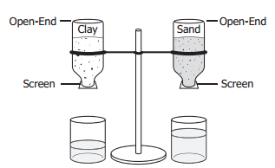 (2009-5) Students want to learn which of two soils holds more water. They put clay in one bottle and sand in the other. Then they put equal amounts of water in the bottles. Some of the water drained into beakers. Which of these is the manipulated, independent variable?
22. Type of soil
23. Type of beaker
24. Amount of water
25. Number of bottles

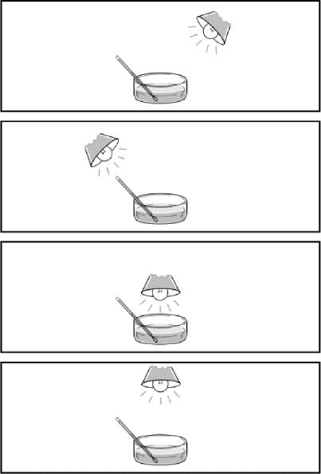

1. (2004-40) The pictures above show how one student tried to see how the heat from a light bulb affected the rate of evaporation of a liquid. What is the only variable being changed in this experiment?
2. The size of the container
3. The position of the thermometer
4. The position of the light bulb
5. The amount of water

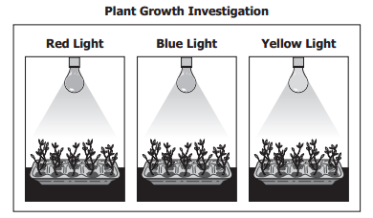

1. (2011-11) A student designed an investigation to test the effect of light color on plant growth. What was the manipulated (independent) variable in the investigation?
2. Color of light bulb
3. Height of plant
4. Hours of light
5. Size of pot

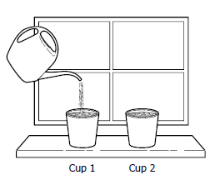

1. (2010-21) Students planted bean seeds in the same kind of soil in separate cups. The cups were put next to each other on a sunny windowsill. Cup 1 was given 10 mL of water every other day. Cup 2 was given no water. Which of these is the independent (manipulated) variable in the experiment?
2. The type of soil
3. The type of seed
4. The amount of water
5. The amount of sunlight

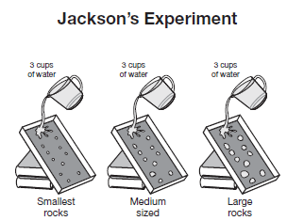

1. (2007-16) In an experiment, Jackson tested to see how the size of rocks affects the amount of dirt that washes away when water flows downhill. Which variable was manipulated?
2. Amount of water
3. Slope of the hill
4. Size of the rocks
5. Type of dirt
6. (2007-22) Sandy is conducting an investigation to find out which food his dog likes best. Which is the manipulated variable in his investigation?
7. The color of his dog’s food dish
8. The kind of food he gives his dog
9. The amount of food he gives his dog
10. The time of day he feeds his dog
11. (2002-24) Todd observes that his strawberry plant has grown little green strawberries. Which of these is a prediction Todd might make about his strawberry plant?
12. The green berries will ripen into red berries.
13. The strawberry plant is growing under an oak tree.
14. The strawberry plant doesn't have enough water.
15. The green berries are a new type of strawberry.
16. (2002-11) Which of these is the fairest way to find out if sand or silt will settle faster when mixed with water? (b)

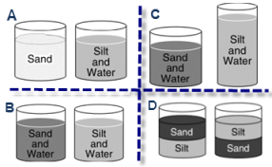

1. (2005-29) A student wants to show how much the use of gasoline has increased over the last ten years. This information would best be displayed in a —
2. Diagram
3. bar graph
4. line graph
5. stem-and-leaf plot
6. (2000-6) Students want to find out if an empty can rolls down a ramp faster than a can filled with sand. Which of these would be the fairest way to find out? (d)

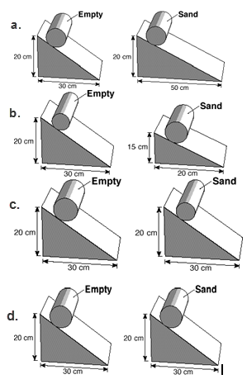

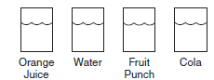

1. (2007-11) A student thinks that orange juice will freeze faster than any other substance. She fills identical containers with the same amount of different liquids, then places each in the freezer. She checks them every five minutes and discovers that the orange juice is the last one to freeze and the water is the first to freeze. Which should the student do next?
2. Change her results to match her original hypothesis.
3. Repeat her investigation to see if her results are the same.
4. Conclude that investigations can only be performed on water.
5. Tell her friends that investigations at school work better than at home.
6. (2004-14) Which is the **fairest** way to find out if salt water boils faster than fresh water? (a)

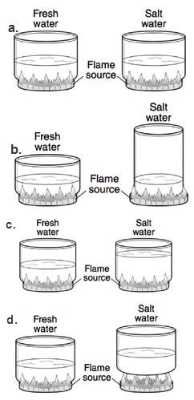

Classification

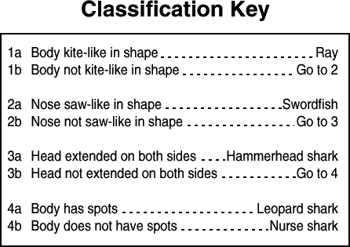

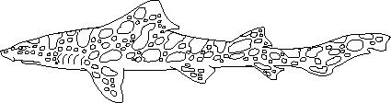

1. (2001-1) Using the picture and classification key, what is this animal?
2. Swordfish
3. Hammerhead shark
4. Leopard shark
5. Nurse shark

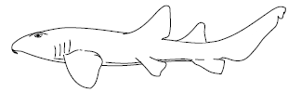

1. (2004-28) Using the picture and classification key, what is this animal?
2. Swordfish
3. Hammerhead shark
4. Leopard shark
5. Nurse shark

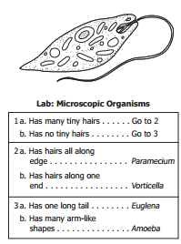

1. (2009-39) Lee uses a microscope during science class. He sees this organism in a drop of water. Which organism did he most likely see?(identification key)
2. Paramecium
3. Vorticella
4. Euglena
5. Amoeba
6. 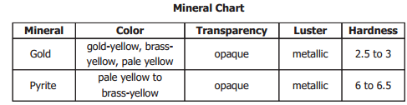(2011-27) Based on the information in the table, the best way to tell gold from pyrite is by which property?
7. Color
8. Transparency
9. Luster
10. Hardness

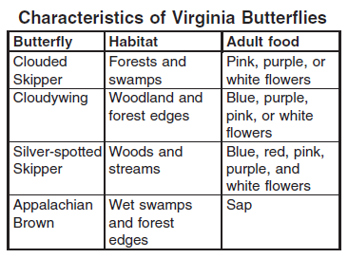

1. (2005-13) Plants use their location and flower color to attract pollinators. A plant with red flowers living along a woodland stream would most likely be pollinated by which of these butterflies?
2. Clouded Skipper
3. Cloudywing
4. Silver-spotted Skipper
5. Appalachian Brown

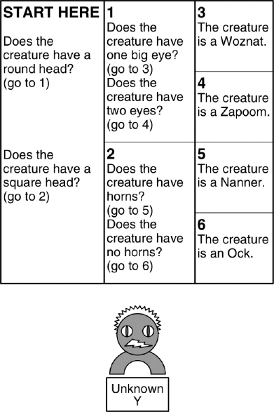

1. (2003-35) According to the identification key, what type of creature is creature Y?
2. Woznat
3. Zapoom
4. Nanner
5. Ock

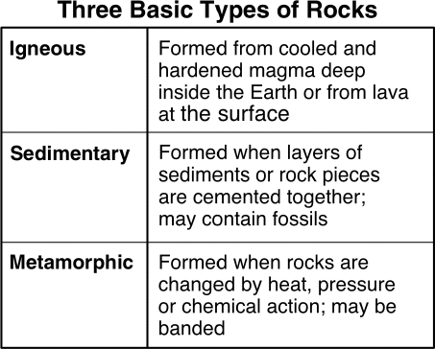

1. (2002-5) According to the information in the chart, which of the following rocks is a sedimentary rock? (a)

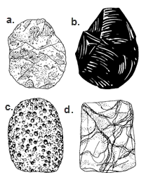

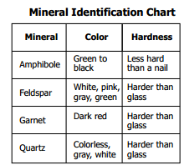

1. (2010-2) A student observes a mineral that is colorless and harder than glass. Based on the chart, which mineral is the student observing?
2. Amphibole
3. Feldspar
4. Garnet
5. Quartz

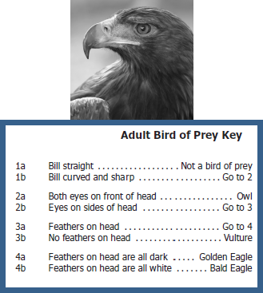

1. (2008-29) Based on the bird of prey key, which bird is shown in the picture? (identification key)
2. Owl
3. Vulture
4. Golden eagle
5. Bald eagle

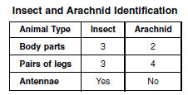

1. (2006-3) According to the table, which animal is **an arachnid? (a)**

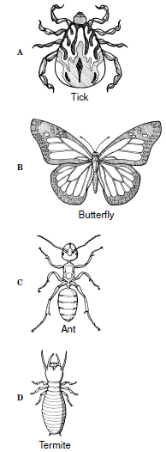

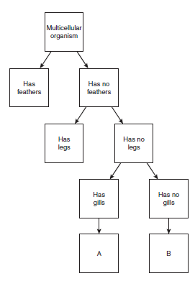

1. (2007-3) Which of these belongs in square A of this flow chart?
2. Bird
3. Toad
4. Snake
5. Fish

Data, Tables and Graphs

1. (2011-21)

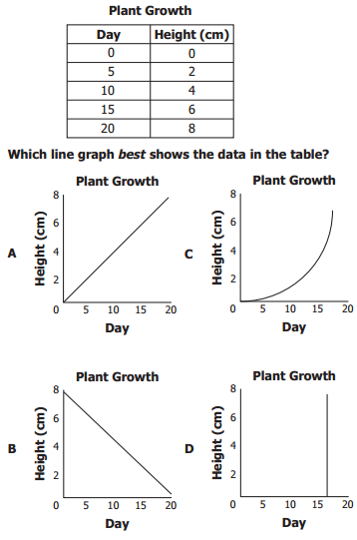

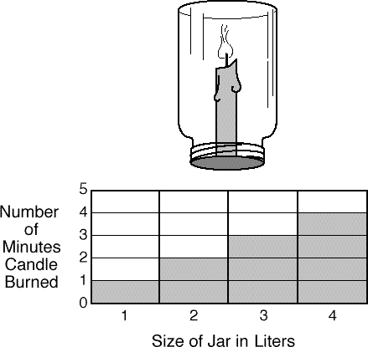

1. (2000-9) The graph shows what happened when a candle was burned in different jars. The results of this experiment show that the bigger the jar, the
2. faster the candle melted
3. longer the candle burned
4. brighter the candle's flame
5. higher the candle's flame
6. (2001-40) How big would a jar have to be to keep the candle burning for 5 minutes? (refer to table from previous question).
7. 1 liter
8. 5 liters
9. 10 liters
10. 15 liters

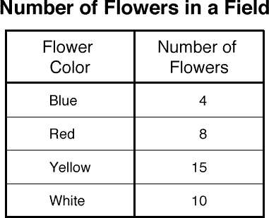

1. (2000-2) The chart shows the number of flowers seen in a field. Which of these best shows these data? ( c )

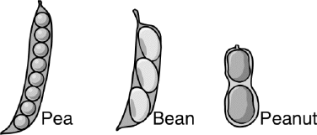

1. (2003-22) The picture above shows some different kinds of seed pods. Which graph correctly shows the number of seeds in each pod? (b)

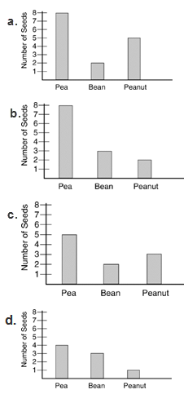

1. (2009-9) A student is writing a report on recycling. The student learns that different kinds of material are recycled in different amounts. Which graph best shows the data? (a)

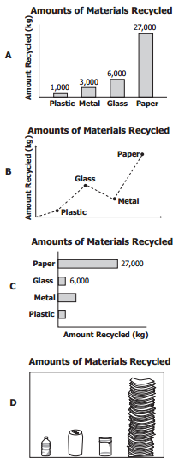

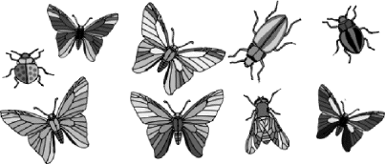

1. (2005-3) The picture shows some insects Dana saw while she was out walking. Which graph best represents what Dana saw? ( c )

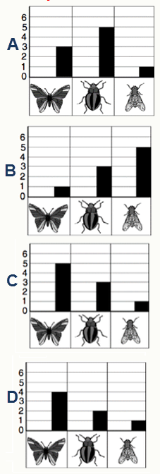

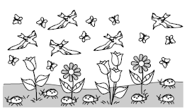

1. (2006-29) The picture shows some animals. Which graph most accurately shows the number of animals in the picture? ( c )

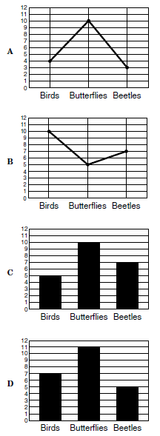

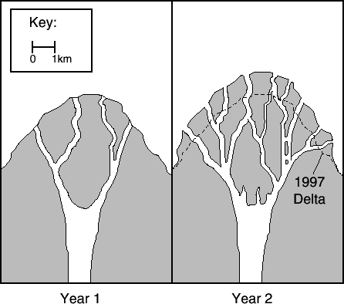

1. (2001-15) The picture shows the development of a delta over a two-year period. According to this information, about how far did the delta reach into the ocean after 1997?
2. 0.1km
3. 0.5 km
4. 1 km
5. 1.5 km

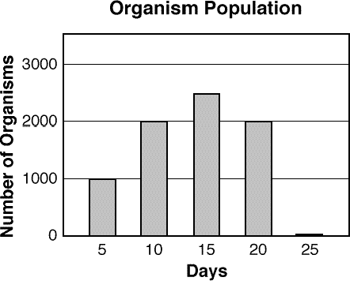

1. (2000-7) Jack grew some very small organisms in a jar of pond water. Each day, he counted the number of organisms he saw on a slide. Then he estimated how many organisms were in the jar. On what day were almost all of the organisms dead?
2. 5
3. 15
4. 20
5. 25
6. (2007-34) (use same graph) Jack grew some very small organisms in a jar of pond water. Each day, he counted the number of organisms he saw on a slide. Then he estimated how many organisms were in the jar. About how many organisms did he estimate were in the jar on day 15?
7. 1000
8. 1500
9. 2000
10. 2500
11. 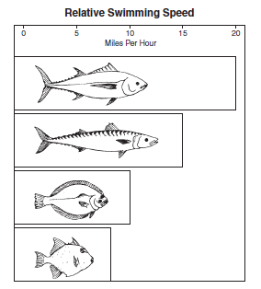 (2007-36) Which of these is probably the slowest fish?( c )

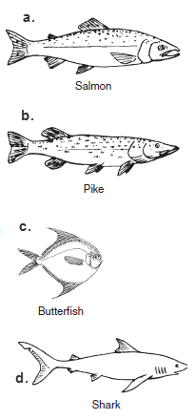

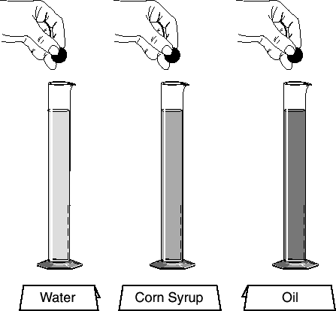

1. (2001-31) A student uses the equipment shown above to study which liquid is the thickest. What information is the most appropriate to record?
2. The height of each of the graduated cylinders
3. The time it takes for each marble to hit bottom
4. The size and mass of each of the marbles
5. The volume of each of the liquids in the cylinders

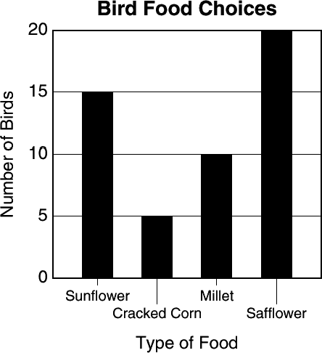

1. (2001-39) According to the graph, which combination of food would probably bring the most birds to the feeder?
2. Sunflower seeds and cracked corn
3. Cracked corn and millet
4. Millet and safflower seeds
5. Sunflower and safflower seeds
6. 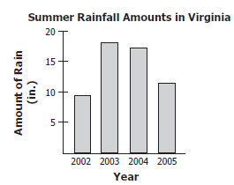 (2008-6) The graph shows the amount of rain that fell during the summer for each of four years. Weather data show that the average rainfall during the summer is about 12 inches. Based on the graph, rainfall was closest to the average during —
7. 2002
8. 2003
9. 2004
10. 2005

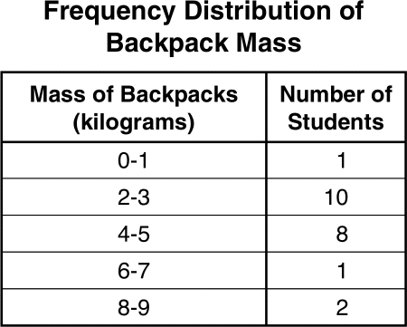

1. (2002-12) Students in Mrs. Smith's class are trying to find the average mass of fifth-grade students' backpacks. The information is displayed on the chart above. The chart shows that fifth-grade students most frequently have backpacks with a mass of –
2. 2-3 kilograms
3. 4-5 kilograms
4. 6-7 kilograms
5. 8-9 kilograms

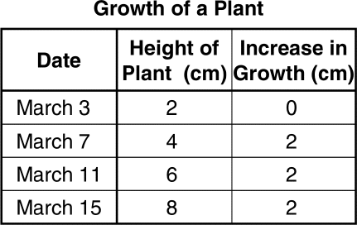

1. (2002-31) Based on the information in the chart, what would be the height of the plant on March 23?
2. 10 cm
3. 12 cm
4. 4 cm
5. 16 cm

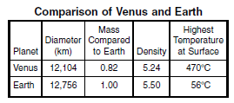

1. (2006-20) The table above compares some facts about Venus with some facts about the planet Earth. How are the two planets most different?
2. Diameter
3. Mass
4. Density
5. Surface temperature
6. 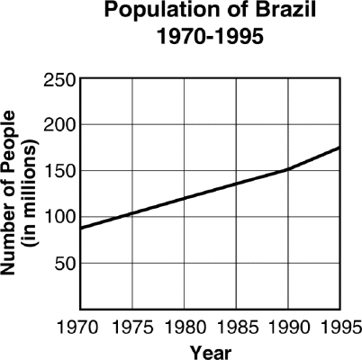
7. (2003-10) From the chart shown above, you can predict that for the year 2000, Brazil's population will –
8. show a heavy drop
9. be a flat line even with 1995
10. have topped 250 million
11. continue its steady rise
12. (2009-32) A boy placed four leaves in a caterpillar’s cage.

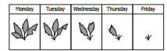

He observed the number of leaves in the caterpillar’s cage each day. Based on the data, the boy should infer that the caterpillar —

1. is eating only every other day
2. is eating each day
3. will eat part of one leaf next Monday
4. will stop eating during molting on Friday

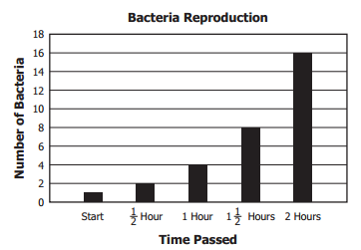

1. (2011-17) On a graph, students recorded how quickly bacteria reproduced over two hours. If the rate of reproduction stayed the same, how many bacteria would be present after 2 ½ hours?
2. 8
3. 16
4. 32
5. 64

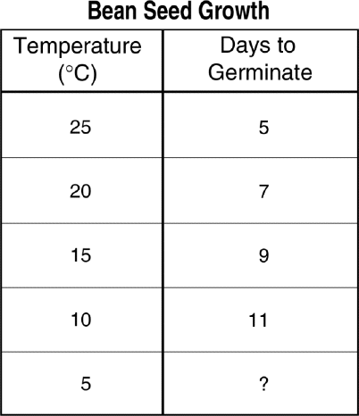

1. (2003-26) The chart shows the time it took for bean seeds to germinate at different temperatures. If the trend continues, at a temperature of 5°C the seeds probably will germinate in -
2. 5 days
3. 8 days
4. 13 days
5. 16 days

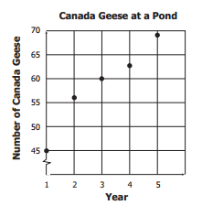

1. (2009-29) A student counted the number of Canada geese that have lived on a pond for the past five years. Based on the graph, how many geese will probably live on the pond in year 6? (prediction based on data)
2. 60
3. 65
4. 70
5. 75

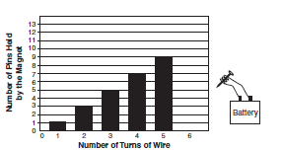

1. (2005-40)The picture shows the results of an experiment with an electromagnet. If the magnet had 6 turns of wire, how many pins would it probably pick up?
2. 9
3. 10
4. 11
5. 12

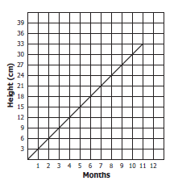

1. (2008-4) The graph shows the height change of a plant over a period of 11 months. How tall should the plant be at month 12 if all conditions remain the same and the plant continues to grow at the same rate?
2. 36 cm
3. 39 cm
4. 42 cm
5. 45 cm

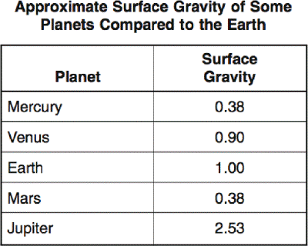

1. (2004-20) The larger the mass of a planet, the greater the pull of gravity on that planet's surface. According to the information in the chart, which of these planets has a mass closest to the Earth's mass?
2. Mercury
3. Venus
4. Mars
5. Jupiter

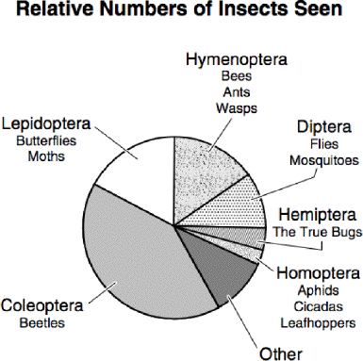

1. (2004-24)) A science class went on a field trip and made a graph of the different kinds of insects that they saw. Which group of insects was seen the most? ©

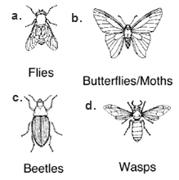

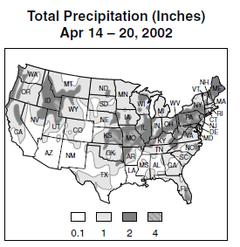

1. (2006-38) According to this precipitation map of the continental United States, which of the following states would be the *least likely* to have floods for this weather period?
2. Arizona (AZ)
3. Florida (FL)
4. Oregon (OR)
5. Virginia (VA)

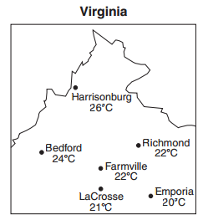

1. (2011-29) Which statement is supported by the data on this map?
2. Emporia is colder than Bedford at the time of these measurements.
3. Bedford is the hottest city in the state of Virginia.
4. LaCrosse will become cooler over the next few days.
5. Richmond, Farmville, and LaCrosse are all colder than Emporia.

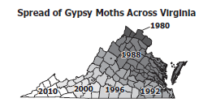

1. (2008-2) The map shows how gypsy moths have spread across Virginia over the years. Based on the map, gypsy moths —
2. live in every state in the United States
3. will be in all of Virginia by 2010
4. first came to Virginia in 1960
5. stopped spreading in 1996

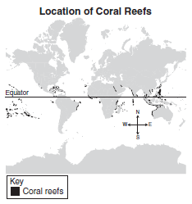

1. (2007-19) Many species of ocean organisms live in coral reefs. The map shows that most coral reefs are found near the equator. What does the location of coral reefs suggest about coral organisms?
2. Corals need warm seawater to survive.
3. Corals mostly live around volcanic islands.
4. Ocean currents keep corals from migrating.
5. Most ocean waters are too deep for corals.

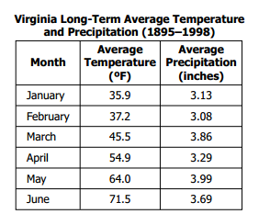

1. (2010-11) A teacher asked his class to help plan their science field trip schedule from January to June. Based on the table, which month with an average temperature above 50°F has the least amount of average precipitation?
2. March
3. April
4. May
5. June

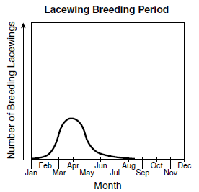

1. (2006-11) The lacewing is a common small insect. The graph shows the breeding period of one species of lacewing. During what season would most of these lacewings breed?
2. Winter
3. Summer
4. Spring
5. Fall

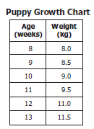

1. (2008-27) Based on the chart, between which two weeks did the growth pattern of the puppy change?
2. 8–9 weeks
3. 9–10 weeks
4. 10–11 weeks
5. 11–12 weeks

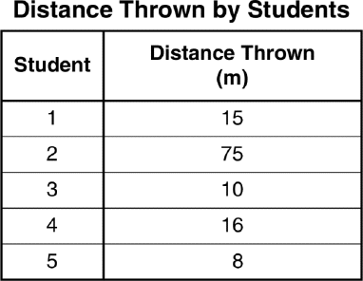

1. (2003-5) Dennis conducted an experiment to determine which of his classmates could throw a ball the farthest. He recorded his results in the above table. Which student's measurement is an **unusual** result?
2. 1
3. 2
4. 3
5. 4

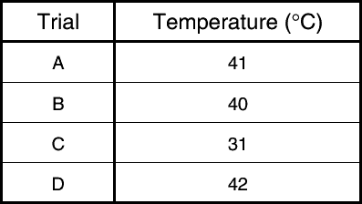

1. (2001-22) Students conducted an experiment in which they rubbed their palms together to warm their hands, then measured the temperature of their hands. The experiment was conducted 4 times. According to the data in the table, which of these trials is most unusual?
2. A
3. B
4. C
5. D

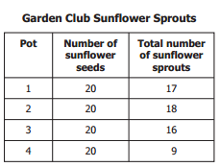

1. (2011-31) The school garden club planted sunflower seeds in 6-inch pots. Each pot was watered the same amount every two days. At the end of one month, the number of sprouts was counted. Which pot had an unusual number of sprouts?
2. 1
3. 2
4. 3
5. 4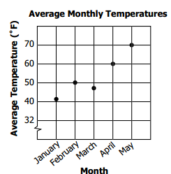
6. (2010-4) Temperatures normally increase every month from January through August. During which month was the average temperature most unusual?
7. January
8. February
9. March
10. April

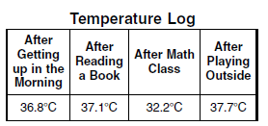

1. (2006-39) A student used a thermometer to take his temperature at different times. He wrote down his measurements in a table. When did the student *most likely* record the temperature inaccurately?
2. After getting up in the morning
3. After reading a book
4. After math class
5. After playing outside

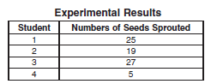

1. (2005-37) Some students recorded the number of bean seeds that sprouted in their experimental plots. Each student began with the same number and type of seeds, the same type of soil plot, and the same amount of water and sunlight. Which of the following students most likely made an error in the experiment?
2. 1
3. 2
4. 3
5. 4