NAME______________________

DATE

GRADE 4/5 – SCIENCE SOL 4.6 WEATHER REVIEW –

(2010 STANDARDS)

1. A scientist who studies weather is called a:
   1. zoologist.
   2. etymologist.
   3. meteorologist.
2. Which is not a form of precipitation?
   1. Rain
   2. Snow
   3. Fog
   4. Sleet
   5. Freezing rain
   6. Hail
3. The movement of air is:
   1. air force.
   2. wind.
   3. thunder.
4. What is the average weather conditions in an area over a period of years called?
   1. temperature
   2. climate
   3. season

AN ANEMOMETER

anemometer

1. The speed of the wind is measured by:
   1. a weather vane.
   2. a wind gauge.
   3. an anemometer.
2. Air temperature is measured by:
   1. a weather gauge.
   2. a thermometer.
   3. an anemometer.

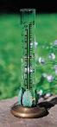

A RAIN GAUGE

1. A rain gauge measures:
   1. the type of precipitation.
   2. the amount of precipitation.
   3. air pressure.
2. You could make a very simple rain gauge by putting a measuring cup or graduated cylinder outside before a rain, and checking the amount of rainfall after the rain.
   1. true
   2. false

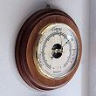BAROMETER

1. A barometer measures:
   1. wind.
   2. air pressure.
   3. bars.
2. A rising barometer usually means:
   1. clear, cooler weather ahead
   2. warmer, rainy weather ahead.
3. Molecules in _____ air are closer together.
   1. warm
   2. cool
4. Air pressure is the weight of the air. Which would weigh more and cause more air pressure?
   1. warm air
   2. cool air

Remember,:

Cool, dry air=high air pressure

Wet, warmer air = low air pressure .

1. A falling barometer, indicates:
   1. the temperature might be warming up.
   2. rain is likely
   3. both
2. Air has weight. _______________ is the force exerted by the weight of the air.
   1. Air pressure
   2. Wind
   3. Rain
3. Low or falling air pressure is usually associated with:
   1. rain or snow
   2. sunny weather

(think of feeling low on rainy days)

1. What instrument is used to measure air pressure?
   1. Anemometer
   2. Barometer
   3. Thermometer

# AIR MASSES AND FRONTS

An air mass is a large body of air with the same temperature and moisture. When air masses bump into each other, you get changes in the weather and precipitation.

1. Air mass #1 is coming from the northwest. It is bringing -
   1. cold, dry air.
   2. warm moist air.
2. Air mass #2 is coming from the southwest. It is bringing:
   1. warm moist air.
   2. cold dry air.
3. Air masses usually:
   1. move
   2. stay still.
4. Air masses in the U.S. generally move:
   1. from east to west.
   2. from west to east
5. If a cold air mass is over Chicago (located to our west), and a warm air mass is over New York (located to our east), what will our weather probably be in a few days?
   1. warm
   2. cold
6. The boundary between two air masses is called a _______.
   1. dog
   2. front
   3. tornado
7. Along a front, the weather is often:
   1. clear
   2. rainy
8. We say a ___ is approaching when a cold air mass is pushing out a warm air mass.
   1. cold front
   2. warm front

WARM FRONT – Lighter, warm air is lifted up over the cold air in a gradual way.

As the air rises, it cools, and if enough water vapor condenses, widespread clouds and precipitation develop. As the front gets closer, the clouds thicken and eventually light precipitation begins to fall. Because the upward slope is gentler than in a cold front, lighter, steadier precipitation is more likely.

A WARM FRONT

1. Along a warm front:
   1. a cold air mass is pushing away the warm air mass in front of it.
   2. a warm air mass is pushing out a cold air mass.
2. In addition to a change in temperature, fronts often bring:
   1. precipitation
   2. hurricanes
3. A cold front will often bring:
   1. a period of steady rain or drizzle followed by warming temperatures.
   2. thunderstorms, or brief heavy rains, or showers, followed by sunshine and cool weather.

A COLD FRONT

As the cold air mass wedges into the warmer air mass, the warmer, less dense air is lifted upwards by the denser cold air and if enough water vapor condenses, clouds develop

Due to the steep slope of a cold front, a sudden rising motion is often produced, leading to the development of showers and occasionally severe thunderstorms.

1. The sketch above shows how a cold front advances. It hits the warm front head on causing:
   1. warm air to get pushed up quickly.
   2. warm air to cool quickly as it is pushed up higher in the atmosphere, where the temperature is cooler
   3. The moist air from the warm front to condense quickly, causing a sudden downpour, storm, or shower.
   4. All of the above
2. The sketch above shows that a cold front causes a:
   1. A very fast change in temperature.
   2. A slow and gradual change
3. The weather change associated with a cold front is:
   1. very rapid
   2. very gradual.
4. A cold front will bring:
   1. colder weather.
   2. warmer weather.

CLOUDS

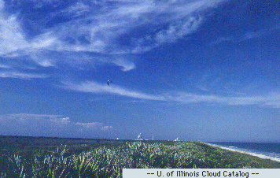

**Cirrus Clouds**

Thin and wispy, feather-like

High in the sky.

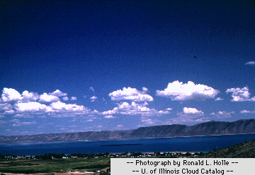

**Cumulus Clouds**

Puffy cotton balls floating in the sky. Lower than cirrus. NO rain.

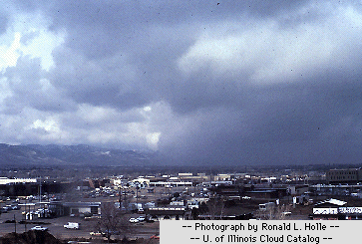

**Stratus Clouds**

RAIN clouds. Steady rain or snow.

Form a dark, wet, blanket on the sky. Stratus means layer

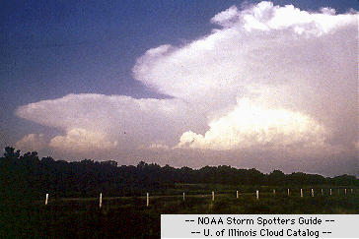

**Cumulonimbus Clouds**

STORM clouds. Nimbus means rain..Puffy, like Cumulus, but bigger and darker. Thunderstorm clouds

1. A stratus cloud looks like:
   1. a cotton ball.
   2. a funnel cloud.
   3. a flat, gray blanket.
2. What kind of cloud is low to the ground, flat and gray, and often brings steady rain or snow?
   1. stratus
   2. cumulous
   3. cumulonimbus
3. Thunderstorm clouds are:
   1. cumulus
   2. stratus
   3. cumulo-nimbus
4. Cirrus clouds look:
   1. thin and wispy.
   2. dark and dangerous.
   3. large and puffy.
5. Cirrus clouds can be found:
   1. high in the sky.
   2. close to the ground.
   3. only in summer.
6. Cumulus clouds are often:
   1. found in a blue summer sky.
   2. indicators of rain coming soon.
   3. thin and featherlike.
7. Cumulonimbus clouds are:
   1. thunderheads that bring stormy weather.
   2. flat and gray.
   3. high in the sky and feather-like.
8. A funnel-shaped cloud is:
   1. a hurricane.
   2. a typhoon.
   3. a tornado.
9. A storm of heavy rain, lightning and strong wind is a:
   1. thunderstorm.
   2. tornado.
   3. blizzard.
10. A blizzard is a:
    1. shake from McDonalds.
    2. very heavy snowstorm.
11. Clouds very close to the ground are called:
    1. stratus.
    2. fog.
    3. cirrus.
12. When “nimbo” is part of a cloud name, you should think of:
    1. sunshine.
    2. rain.
13. Cumulonimbus clouds:
    1. look puffy like cumulous clouds, except they are dark in parts, and usually larger.
    2. extend very high in the sky and widen at the top like anvils.
    3. bring heavy rain, and thunderstorms.
    4. All of the above
14. What is not true about cirrus clouds?
    1. They are the highest clouds.
    2. They are thin and wispy.
    3. They usually bring rain.
15. What is not true about cumulus clouds?
    1. They look like cotton balls.
    2. They are often seen on rainy days.
    3. They are often seen on a blue sky, and they do not threaten rain.
16. On a sunny day, you probably won’t see:
    1. cumulus clouds.
    2. cirrus clouds.
    3. stratus clouds
17. You should get out of the pool if you see this cloud moving in -
    1. cumulus
    2. cumulo-nimbus
    3. cirrus
18. Storms that form over water and carry very high winds are:
    1. thunderstorms.
    2. blizzards.
    3. hurricanes.
19. Hurricanes start:
    1. in the western part of the U.S.
    2. in Europe.
    3. over the Atlantic Ocean near the Gulf of Mexico and the Caribbean

**The following questions were moved to the end of this packet because they cover content that is no longer explicitly mentioned in the revised 2010 science standards.**

-------------------------------------------------------------------------------------------------------------------------------------

WATER CYCLE

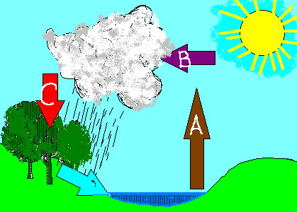

LABEL the 3 stages of the water cycle

( evaporation, condensation, precipitation.).

1. The diagram above shows:
   1. a life cycle.
   2. the water cycle.
   3. a thunderstorm.
2. The _______drives the water cycle.
   1. clouds
   2. sun
   3. moon
3. Energy from the sun warms the water on earth causing it to:
   1. disappear
   2. condense
   3. evaporate
4. When water evaporates it becomes:
   1. clouds.
   2. water vapor.
   3. wind.
5. Clouds are formed when:
   1. warm, moist air rises and cools.
   2. dust particles come together.
   3. there is high humidity.
6. Water vapor is water in the ____ state.
   1. solid
   2. liquid
   3. gas
7. As the warm moist air rises, it begins to cool, which causes the water vapor in the air to:
   1. evaporate
   2. boil
   3. condense
8. When water vapor (a gas) becomes water (a liquid), this process is called:
   1. boiling
   2. condensation
   3. evaporation
9. Water vapor in the air condenses when it:
   1. warms.
   2. cools.
   3. gets heavy.
10. When water vapor condenses, it forms:
    1. tiny droplets of liquid
    2. clouds
    3. both - Clouds are tiny droplets of liquid.
11. As more and more tiny droplets of liquid form, they combine and get heavier. What happens next?
    1. Nothing
    2. They fall as precipitation
    3. They cause thunder
12. Clouds are made of:
    1. gas
    2. tiny drops of water
    3. frogs
13. When water droplets get big and heavy, this occurs:
    1. precipitation.
    2. hibernation.
    3. evaporation
14. Fog is actually:
    1. a low stratus cloud.
    2. smoke.
    3. pollution.
15. ______ is the amount of water vapor in the air.
    1. Air pressure
    2. Humidity
    3. The dew point
16. This instrument is used to measure humidity:
    1. an anemometer
    2. a spectrascope.
    3. a hygrometer

Hint for the last question - think or the “h” in both humidity - hygrometer)

1. Wind speed is measured by an anemometer and wind direction is measured by a:
   1. anemometer
   2. barometer
   3. weather vane

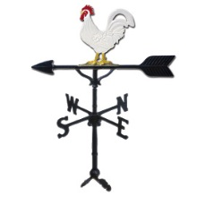

1. This instrument is a
   1. weather vane
   2. rain gauge
   3. an anemometer

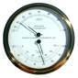 HYGROMETER

1. A hygrometer measures:
   1. air speed.
   2. rain.
   3. humidity.
2. The amount of water vapor in the air is the _________ of the air.
   1. pressure
   2. humidity
   3. temperature
3. A hygrometer measures the amount of ____ in the air.
   1. water vapor
   2. pollution
   3. smoke
4. Weather satellites are:
   1. devices that collect precipitation in space.
   2. machines that orbit the Earth to measure wind speed.
   3. instruments in space that collect weather data and take pictures of cloud cover.
5. A weather satellite can _________weather.
   1. predict
   2. track
   3. control
   4. change
   5. none of the above

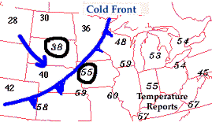

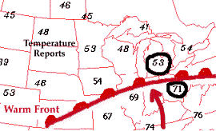

1. On a weather map, which front is indicated by a curved line with sharp spikes?
   1. A cold front
   2. A warm front
2. On a weather map, the symbol for a warm front is:
   1. a line with triangular, sharp spikes.
   2. a curved line with rounded bumps.
3. On a weather map, the symbol for a cold front is:
   1. a line with triangular, sharp spikes
   2. a curved line with rounded bumps.