DRAGGER GAME 1
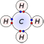
Bond formed when atoms share electrons (usually two nonmetals)
--covalent bond

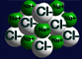
Bond formed when one atom (a metal) loses electrons and the other (a nonmetal) gains electrons
--ionic bond

Atom that has lost or gained an electron
-- ion

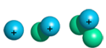
Atom that has gained or lost a neutron
--isotope

Atom that has gained or lost a proton
--a new element

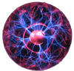
4th state of matter; occurs under extreme heat
--plasma

DRAGGER GAME 2

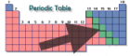
Elements located on the stair-step line of the periodic table
--metalloids

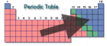
Elements right of the stair-step line on the periodic table
--nonmetals

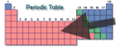
Elements left of the stair-step line on the periodic table
--metals

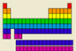
Horizontal rows of periodic table
--periods

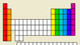

Columns on periodic table
--groups or families

Number of protons in the nucleus
--atomic number
------------------------------------------------------------------------

