Draw lines to connect the explorer to his country of origin, and then to the area they explored.

Giovanni (John) Cabot Southwest United States

France
Francisco Coronado Quebec, Canada

Spain
Robert La Salle Mississippi River Valley

Portugal
Samuel de Champlain Eastern Canada

England
Vasco de Gama West Coast of Africa

************************************************************************
Read the list of issues faced by Western European explorers below. Write the issues that motivated Europeans to explore in the Motivations bubble. Write the issues that were obstacles to European exploration in the Obstacles bubble.

Gold Disease/starvation

Natural Resources Lack of adequate supplies
To Spread Christianity Claim to more land
Fear of unknown Poor maps and navigational tools
People & Places to trade with
Obstacles
Motivations

Read the list of issues faced by Native Americans and European explorers below. Write the issues that caused conflict in the Conflict bubble. Write the issues that led to cooperation in the Cooperation bubble.

Transportation technology Growing Crops
Disease Owning Land
Language differences Competition for trade
Trading goods
Conflicts
Cooperation

************************************************************************
Determine which Western European country, or countries, is/are responsible for the following events. Write S for Spain. Write E for England. Write F for France.

____ Conquered and enslaved Native Americans.

____ Spread Christianity.

____ Brought European diseases.

____ Established trading posts.

____ Established settlements and claimed ownership of land.

____ Learned farming techniques from Native Americans.

____ Treated Native Americans as equals.
Put the three empires in order from oldest to newest.

Mali, Songhai, Ghana

1st _____________________________
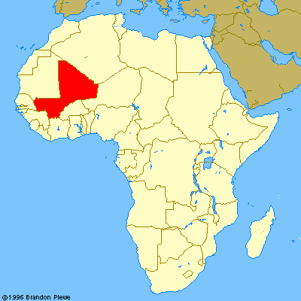

2nd _____________________________

3rd _____________________________

Circle the raw goods that were shipped
out of Mali by Portuguese explorers.

Wool Pumpkins
Gold Cloth
Salt People

