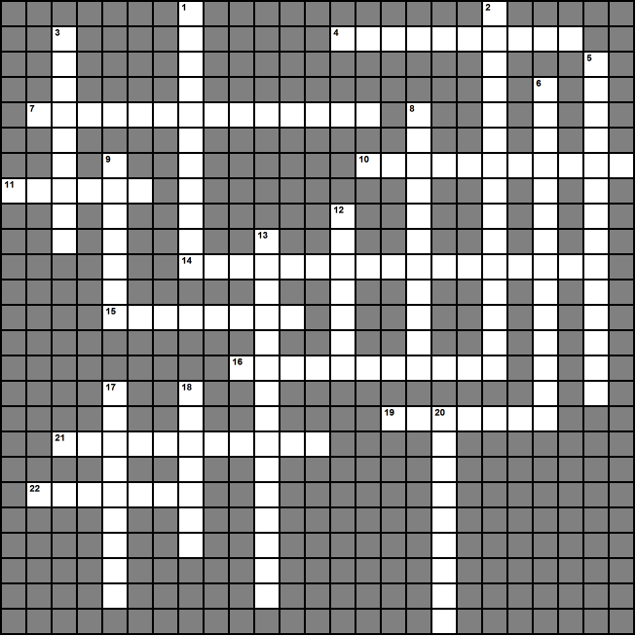
USII.5 US History 1877 to the Present Name_____________________
The Early 1900's Printable Crossword Puzzle
Clues - pg. 2

Permission to duplicate granted to SOLpass subscribers ONLY www.solpass.org

Across  4. A novelist who wrote about the Jazz Age. (last name)  7. Movement of African Americans from southern farms to northern cities during the early 20th century. (2 words)  10. They smuggled alcohol during Prohibition  11. The President who did little to end the Great Depression (last name)  14. A cultural movement of African American artists, writers, and musicians. (two words)  15. A Harlem Renaissance artist who painted scenes depicting the Great Migration north (last name)  16. The sale and consumption of liquor was banned during a period known as______.  19. During the 1920's, high ____ strangled international trade.  21. Illegal places to drink during Prohibition  22. He helped develop the radio broadcast industry | Down  1. A Harlem Renaissance singer of the blues. (first and last name)  2. The biggest economic downturn in U.S. history. (two works)  3. He made cars affordable by using the assembly line to lower production costs. (first and last name)  5. After the collapse of the stock market, the ____ _____ was not used to support banks and to prevent the collapse of the banking system.  6. A Harlem Renaissance poet (first and last name)  8. It crashed in 1929. (two words)  9. Roosevelt's plan to end the Great Depression (two words)  12. He developed the radio  13. Powered many labor-saving devices in American homes  17. A novelist who wrote about migrant farm workers during the 1930s.  18. An artist known for urban scenes, flower portraits, paintings of the Southwest. (last name)  20. The President who used government spending to jump-start the economy and end the Great Depression. (last name)

